Public Water Feasibility Study
For The
Town of New Gloucester, Maine

June 15, 2011

Prepared by:

Drumlin Environmental, LLC

Town of New Gloucester Planning Department

EXECUTIVE SUMMARY
The purpose of this report is to describe the investigation and planning undertaken by the Town and Maine DEP to determine the practicality and potential cost of constructing a public water system to provide reliable, clean water to residents and businesses in Upper Village.

Underground gasoline storage tank failures in the Upper Village have led to the detection of benzene and/or MTBE in 22 Upper Village water supplies. Five water supplies have benzene and/or MTBE concentrations above human consumption levels. Also, seven Upper Village water supplies exceed U.S. EPA drinking water standards for sodium, and eight water supplies exceed the drinking water standards for chloride. Maine DEP and the Town currently provide temporary household filtering systems at 12 locations in the Upper Village. However, the household filtering systems are both costly and prone to malfunction. Recent Memorial School water supply test results indicate uranium levels twice the U.S. EPA drinking water standards. MSAD 15 currently provides anion exchange filtering to reduce uranium concentrations to acceptable levels.

In addition to public health concerns, water supply contamination contributes to a lack of economic investment in the Upper Village.

An Upper Village water system would provide reliable, high quality drinking water to current and future residents, businesses and town facilities in the vicinity of the contamination. Improved fire protection could also be available.

The proposed water system would serve up to 88 current residences and a number of non-residential land uses including town facilities, Memorial School, manufacturers, day care centers, restaurants, and clubs. The preliminary components and extent of the Upper Village water system are depicted on Figure 1: Preliminary Area of Proposed Water System. Estimated average demand of an Upper Village water system is approximately 25 gallons per minute (gpm). The water system could be supplied by a well located at the New Gloucester Fairgrounds or by extension of an Auburn Water District main.

Comprehensive investigation has been conducted by hydrogeologic and engineering consultant Drumlin Environmental, LLC of Portland, under a contract funded jointly by the Maine DEP and the Town. Drumlin has recently completed testing of the deep sand and gravel and bedrock aquifer that lies west of the Royal River. This aquifer has high quality water and can produce at least 60 gpm, more than twice the anticipated demand. Water from this aquifer will require only minimal treatment to remove radon.

The quality of groundwater in the deep aquifer system underlying the Fairgrounds is naturally protected by a barrier of low permeability soil that also extends over the area. Testing of the aquifer has not shown evidence that current land use activities have affected the quality of the water. In order to protect the quality of the water supply in the deep aquifer under the Fairgrounds, specific land use measures and practices would be developed during the design process in consultation with the Drinking Water Program. Examples would include:
- Establishing a protective, low use area around the well. (This area would not be likely to limit use of the current soccer fields.)
- Controlling the use of fertilizers on the Fairgrounds.
- Limiting access to vehicles by providing convenient parking at the east end of the fairground track.

Alternatively, the Upper Village water system could be supplied through a connection to the Auburn Water District (AWD), which draws water from Lake Auburn. A transmission main would be extended across the railroad and south along Route 100/202 to the Auburn border with New Gloucester. A booster station would be constructed in this area and the transmission main would be extended along Route 100/202.

The following table provides a summary of projected costs for both alternatives:
Component | New Gloucester Source | Auburn Source
Upper Village Distribution | $ 1,692,000 | $1,692,000
Water Source | $ 560,000 | $1,332,000
Legal, Admin, Engineering Permits, Fundraising | $ 235,000 | $255,000
TOTAL ESTIMATE: | $ 2,487,000 | $ 3,279,000

There are several options to administer and operate the Upper Village water system.
Join Yarmouth Water District (YWD) If a New Gloucester water source is chosen, the system could join and be operated by YWD, which currently operates the Pineland public water system.
Create The New Gloucester Water District If a New Gloucester water source is chosen, a New Gloucester Water District could be created and administered by a Town appointed board. It could be operated by its own staff, or operated by a neighboring water district or consulting firm on a contract basis.
Join Auburn Water District (AWD) If New Gloucester chooses to connect to the Auburn water system, AWD would consider either selling New Gloucester bulk water or incorporating the New Gloucester area into their district.

The choice of administrative option will also impact the town’s ability to acquire project capital. There are a number of potential funding sources and the construction of the Upper Village water system is likely to utilize several of these sources.
Maine Department of Environmental Protection -- To-date Maine DEP has paid for 50 percent of all costs related to system exploration and preliminary engineering. The DEP anticipates funding the Upper Village water system based on the percentage of hook-ups with oil-contaminated or at-risk water supplies (e.g., the DEP would likely fund 25% of the Upper Village system if 25 of 100 services were at risk of oil contamination).
Maine Drinking Water Program Capacity Development Grants – Up to $15,000 could be available from the Maine DWP for planning and engineering associated with increasing the capacity of a water system.
Maine Drinking Water Program- State Revolving Loan Fund – The SRF program offers long-term low interest loans at two percent below the Maine Municipal Bond Bank rate and funds the majority of water projects in Maine. Projects must qualify for the program based on a competitive scoring system, but projects addressing contaminated and at-risk water supply issues generally score high. If households in the new system service area meet specific income qualification requirements, a portion of the loan may be forgiven.
Cumberland County Community Development Block Grant (CDBG) – Public Facilities Program The Upper Village water system is eligible for Cumberland County CDBG funds and New Gloucester has been encouraged to apply. Ideally, the application amount should represent what is needed to complete the project budget after DEP and SRF funding. Application amounts are constrained by the total annual Cumberland County CDBG program budget. A request would likely range between $200,000 and $300,000.

Cost allocations for this multi-year project can be found in Table 5 of the report.

Following review of the Feasibility Study results, on May 23, 2011 the New Gloucester Selectmen voted to support? a future water system supplied from a New Gloucester source, based upon: 1) high water quality; 2) long-term pump tested well capacity; 3) construction costs estimated at $792,000 less than the Auburn; and 4) consistency with New Gloucester planning efforts. The purpose of this decision is to allow additional research to be focused and to move efficiently toward a future town meeting project vote.

Anticipated next steps during 2011 include:
- A community Public Water workshop scheduled for Wednesday, June 29th .
- DWP permitting of the source, enabling the Town to apply for additional grant funding.
- Determine whether project area meets Drinking Water State Revolving Loan Fund “disadvantaged community” definition.
- Analyze funding benefits, costs, debt service and projected rates to evaluate remaining administrative options.
- Conduct the preliminary engineering analysis and develop the basis of design to guide detailed design of the water system.
- Seek special town meeting in Fall 2011 for town project vote. This date will help facilitate 2012 CDBG funding deadlines.

I. PURPOSE OF THE WATER SYSTEM

Contamination History / Conditions
Sampling in the Upper Village has detected the presence of gasoline or gasoline constituents in 22 water supplies. The majority of these are very low levels of contamination, but 5 water supplies have concentrations above acceptable levels for human consumption. Chemical constituents of gasoline, such as Benzene, are known carcinogens. The sources of gasoline contamination are assumed to be service station and automobile repair facilities in the Upper Village. This is an area where historically multiple spills are known to have occurred, including:

- A series of spills have been documented at the former site of Samson’s Garage & Gerry’s Gas and Tire. For example, in 1995 Maine DEP removed 1,568 tons of petroleum contaminated soil from the site following Underground Storage Tank (UST) failure.
- In 1994 Maine DEP removed 1,350 cubic yards of petroleum contaminated soil from Cloutier’s Market following UST failure.
- In 1997 Maine DEP removed 500 cubic yards of petroleum contaminated soil from Wings Tank and Tummy following UST failure.

Sampling in the Upper Village also detected the presence of sodium and/or chloride in 33 water supplies. Seven water supplies exceeded U.S. EPA drinking water standards for sodium. Eight water supplies exceeded U.S. EPA drinking water standards for chloride. While the source of salt and chloride contamination is not conclusively known, the former Town salt pile, replaced with a roofed facility in 1987 is one possible source.

Given the scope of the problem and difficulties encountered drilling replacement water supplies, DEP and the Town have pursued the temporary strategy of providing household filtering systems. Four water supplies are currently receiving DEP filtering, and at least one receives private filtering, for gasoline contamination. Eight water supplies are currently receiving Town filtering for salt and chloride contamination. However, the household filtering systems are both costly and prone to malfunction. Importantly, the contaminated water supply also contributes to a lack of investment in the Upper Village. Business and residential buyers are not assured the availability of clean drinking water. Therefore, Maine DEP and the Town of New Gloucester are vigorously pursuing a public drinking water system to supply the Upper Village.

In addition to contamination related to oil products and salt, the New Gloucester Memorial School public water supply has been found to contain levels of uranium exceeding U.S. EPA drinking water standards. In 2010 samples indicated uranium levels of 63 pCi/l, compared to the drinking water standard of 30 pCi/l. This issue is currently being addressed using anion exchange filtering.

The Town of New Gloucester and Maine DEP have shared the costs of investigating the feasibility of a public water system. During the past four years, comprehensive investigation has been conducted by hydrogeologic and engineering consultant Drumlin Environmental, LLC. Drumlin’s work has focused on assessing whether it would be feasible for the Upper Village water system to be supplied from a local groundwater source.

Drumlin has conducted several phases of investigation including:

- Confirmatory sampling of existing residential wells where sodium and chloride are elevated;
- Evaluating the potential quality and quantity of groundwater available from the Fairgrounds property;
- Assessing the compatibility of using the Fairgrounds property for both a water supply and a recreational resource for the Town; and,
- Evaluating the potential availability of groundwater from alternative large parcels in the vicinity of the Fairgrounds.

During the assessment process Drumlin has provided the Town and Maine DEP with detailed reports describing each phase of the evaluation. These reports are available for review in the New Gloucester Town Office. This report provides a summary of Drumlin’s findings, including preliminary design, costs, and administrative options for a public water system.

II. PROPOSED WATER SYSTEM

The goal of the Upper Village water system would be to provide reliable, high quality drinking water to current and future residents, businesses and town facilities in the vicinity of Upper Village. In addition to drinking water, the system would also provide reliable water for business needs. Depending on the design of the system, improved fire protection could also be available, with the addition of hydrants throughout the area.

Area of Proposed Water System
As part of the planning and assessment activities conducted to date, a conceptual design has been developed that identifies the principle components and extent of an Upper Village water system. This conceptual design would be refined during the preliminary and detailed phases of design, but provides an overview of the major elements.

In order to provide a reliable water supply in the vicinity of Upper Village, the proposed water system would include approximately 14,000 feet of water distribution main serving the following areas:

- Route 100/202 from Route 231 to Gilmore Road;
- Upper Village Road;
- Peacock Hill Road and Gilmore Road;
- Bald Hill Road to the Royal River and the northern end of Snow Hill Road;
- Route 231 to the Memorial School; and
- Bald Hill Road to Wayfarer Village

In addition to the distribution mains, the water system would also include a transmission main connecting to the water source, a pump station at the source and a storage tank. If the system were designed with an elevated water tank, the most suitable location for the storage tank would be in the vicinity of Peacock Hill.

The preliminary components and extent of the Upper Village water system are depicted on Figure 1: Preliminary Area of Proposed Water System which is attached to this report. During the design process, the Town will be able to make modifications and refinements to all aspects of the water system, including service area shown in the attached map.

Anticipated Demand
Town planning staff recently conducted an inventory of residential and other land uses on lots along the route of the water system. This inventory identified 88 residences and a number of non-residential land uses including town facilities (e.g., the school and the garage), manufacturers, day care centers, restaurants, clubs and other land uses.

The Maine Subsurface Wastewater Disposal Rules include tables listing the typical water use for a variety of land uses. The typical water uses in the tables are often somewhat higher than actual uses reported by water districts, but are useful to make conservative estimates of the water requirements for an Upper Village water system.

Based on the Town inventory of land uses and the Wastewater Disposal Rule water demand tables, it is estimated that an Upper Village water system would have an average demand of approximately 25 gallons per minute (gpm) of water. A summary of the demand estimate is included in Appendix A of this report.

Preliminary Estimate of Cost of the Distribution System
A preliminary cost estimate has been developed to construct the water distribution system depicted in Figure 1. The preliminary estimate in Table 1 is based on installation of approximately 13,800 feet of 8-inch distribution main and construction of a 200,000 gallon storage tank near Peacock Hill.

Table 1
Preliminary Cost Estimate of Distribution System

Item | Quantity | Unit Rate | Subtotal
Distribution Main | 13,800 ft | $68/ ft | $938,400
Storage Tank | 1 (200,000 gallons) | $600,000 | $600,000
10% Contingency |  |  | $153,600
TOTAL: |  |  | $1,692,000

This estimate was developed to represent a reasonable low bid cost, based on recent construction costs reported to the Maine Drinking Water Program. These costs could be different at the time of construction due to a variety of factors. A reasonable range of costs for planning purposes would be between $1.3 and $2.0 million dollars.

III. NEW GLOUCESTER WATER SOURCE

The Town and Drumlin, with assistance from the MDEP, has identified a local groundwater source from an aquifer that underlies the area around the Fairgrounds property on Bald Hill Road. It would also be possible to supply water to the Upper Village water system by extending a transmission main south from Auburn and connecting to the Auburn Water District. Both of these source options have been evaluated in order to compare the benefits and costs of each. Information about a New Gloucester water source is discussed in this section. Information about an Auburn Water District source is discussed in Section IV.

New Gloucester Water Source
Drumlin recently completed testing of the deep sand and gravel and bedrock aquifer that lies beneath the area west of the Royal River, including the Fairgrounds property and areas west of the Maine Turnpike. Investigation and testing of this aquifer is described in detail in a March 21, 2011 letter to the Town and MDEP, which is available for review in the New Gloucester Town Office.

Recent Aquifer Testing Results
The testing showed that this aquifer has high quality water and can produce at least 60 gpm, which is more than twice the anticipated demand of the Upper Gloucester water system. Water from this aquifer will require only minimal treatment to remove radon. Based on the testing that was completed, the aquifer can be pumped at a rate of at least several hundred gallons per minute for short periods (several hours). There are also indications that the aquifer could produce more than 60 gpm over the long term. These characteristics mean that this water source could supply the Upper Village water system as it is developed and would also allow for significant growth in the future.

Wellhead Protection
The quality of groundwater in the deep aquifer system underlying the Fairgrounds is naturally protected by a barrier of low permeability soil that also extends over the area. Testing of the aquifer has not shown any evidence that current land use activities have affected the quality of the water.

In order to continue to maintain the high quality of the water from this aquifer, the Town would work with land owners in the area over the aquifer and help them adopt best management practices to limit the possibility that their activities could affect groundwater quality in the future. The Town would also adopt best management practices for Town-owned land in this area. Adopting best management practices would allow use of the deep aquifer for the Upper Village water system and also allow existing land uses within the wellhead protection area to continue.

Currently the New Gloucester Fairgrounds property is used for a number of recreational activities including several soccer fields and the former track which is used regularly by walkers and joggers. The Fairgrounds is also used periodically for community activities including the New Gloucester Fair. These activities could continue if a water supply well was developed on the property because they do not pose a significant threat to water quality and because the deep aquifer is protected by the low permeability soil barrier. Some measures should be implemented to provide protection immediately around the wellhead and some best management practices should be considered in the use of the fairgrounds property. Specific measures and practices would be developed during the design process in consultation with the Drinking Water Program. Some examples would include the following:

- Establishing an area within a 200 to 300 foot radius around the well where no motorized activity or chemical use is conducted except for well maintenance and grounds maintenance. (A 300 foot radius would extend to the edge of (but not include) the current soccer fields.)
- Controlling the use of fertilizers on the Fairgrounds to make sure that the application rate is at or below the uptake rate, so there is no excess applied.
- Limiting access to vehicles by providing convenient parking at the east end of the fairground track.
Educational signs could be used to make residents aware of the importance of using the Fairgrounds in a way that does not pose a threat to the water supply well.

Many of these practices are already being used at the Fairgrounds, so formalizing them would have a minimal effect on current uses.

Preliminary Cost Estimate for New Gloucester Water Source
A preliminary cost estimate has been prepared for developing a well in the deep aquifer that would supply the Upper Village water system. Table 2 includes the primary components involved in developing a well and pump station and connecting it to the Upper Village water system.
Table 2
Preliminary Cost Estimate – New Gloucester Water Source
Item | Quantity | Unit Rate | Subtotal
Additional Aquifer Testing & Permitting (Allowance) | 1 | $40,000 | $40,000
Well & Pump Station | 1 | $250,000 | $250,000
Transmission Main | 2,500 ft | $68/ ft | $170,000
Royal River Crossing | 1 | $50,000 | $50,000
10% Contingency |  |  | $50,000
TOTAL: |  |  | $560,000

This estimate was also developed to represent a reasonable low bid cost, based on recent construction costs. A reasonable range of costs for planning purposes for development of a New Gloucester water source would be between $500,000 and $650,000.

IV. AUBURN WATER DISTRICT SOURCE

The Upper Village water system could also be supplied through a connection to the Auburn Water District (AWD). The AWD draws water from Lake Auburn, which supplies its customers throughout its service territory.

Currently the AWD distribution system extends south on Route 100/202 to the vicinity of Kittyhawk Avenue in Auburn. To provide water to the Upper Village water system, a transmission main would be extended across the railroad and south along Route 100/202 to the Auburn border with New Gloucester. A booster station would be constructed in this area and the transmission main would be extended along Route 100/202 in New Gloucester and connected to the Upper Village water system at Gilmore Road.

Preliminary Cost Estimate for an AWD Water Source
Table 3 summarizes the preliminary cost estimate to extend the transmission main from its current location in Auburn and to construct a booster station.

Table 3
Preliminary Cost Estimate – Auburn Water Source
Item | Quantity | Unit Rate | Subtotal
Transmission Main (current location to New Gloucester) | 7,100 ft | $68/ ft | $482,700
Transmission Main (New Gloucester line to Gilmore Rd) | 6,300 ft | $68/ ft | $428,300
Railroad Bridge Crossing | 1 | $150,000 | $150,000
Booster Station | 1 | $150,000 | $150,000
10% Contingency |  |  | $121,000
TOTAL: |  |  | $1,332,000

This estimate was also developed to represent a reasonable low bid cost, based on recent construction costs reported to the Maine Drinking Water Program. A reasonable range of costs for planning purposes for connection to the Auburn Water District source would be between $1.2 and $1.6 million.

If the Upper Village water system were supplied from a connection to AWD, it would be logical to consider either becoming part of AWD or having AWD operate the Upper Village system under contract.

V. SUMMARY OF ESTIMATED PROJECT COSTS

Section III provides an estimated cost for the Upper Village water distribution system and Sections IV and V provides estimates for water sources from New Gloucester and Auburn. Table 4 summarizes the estimated combined costs, and includes estimates for associated costs (e.g., legal, administration, engineering and permits).

Table 4
Estimated Cost for Upper Village Water System
Component | New Gloucester Source | Auburn Source
Upper Village Distribution | $ 1,692,000 | $1,692,000
Water Source | $ 560,000 | $1,332,000
Legal, Admin, Engineering Permits, Fundraising | $ 235,000 | $255,000
TOTAL ESTIMATE: | $ 2,487,000 | $ 3,279,000

As described earlier in Sections III, IV and V, there is a considerable amount of variability in possible actual costs, due to future prices for pipe and other materials and contracting conditions. There will also be further refinement of the system layout, components and estimated cost during the design phase. Therefore, these costs should be viewed as budgetary estimates.

Table 4 does identify that developing the Upper Village water system using a water source from the deep aquifer at the Fairgrounds is projected to represent the lower cost option. Based on the preliminary level of system planning and potential cost variations, it appears that using a New Gloucester water source would cost between $500,000 and $1,000,000 less than connecting to AWD.

VI. WATER DISTRICT ADMINISTRATION

The following section provides an overview of water district administration options. Choosing a water source (New Gloucester or Auburn extension) will help to narrow the administrative options. An analysis of associated funding benefits, costs, debt service and projected rates will be conducted in the future to evaluate the best options.

Join Neighboring Water District
Compared to most municipal systems, the proposed New Gloucester system is reasonably small in size. It is anticipated to serve approximately 400 to 600 people. Given the staffing, maintenance, and billing responsibilities of operating a water district, the Town may choose to join an existing water district, rather than creating a new district.

Yarmouth Water District
The Yarmouth Water District (YWD) has several affiliations with the Town of New Gloucester. YWD currently operates the Pineland public water system, supplied by a Town owned well. The Yarmouth Water District was originally granted the right to use water from the Towns of Yarmouth and New Gloucester when it was chartered by the Legislature in 1895. In 1993, the Legislature modified the District’s right to use water from New Gloucester by requiring approval from both the Town of New Gloucester and the YWD Trustees.

The YWD has an Aa3 bond rating and the sixth lowest rate in the state. The Town has held discussions with Superintendent, Bob MacKinnon to explore options. According to Superintendent MacKinnon, YWD would consider establishing a satellite rate for the New Gloucester system, which could be used if needed to assist in servicing project construction debt. Joining the YWD would require a vote of the Yarmouth Water District Board of Directors, a modification of their charter, and petition of the Public Utilities Commission.

Auburn Water District
If New Gloucester chooses to connect to the Auburn water system, Auburn Water District would consider either selling New Gloucester bulk water or incorporating the New Gloucester area into their district. The Upper Village system in New Gloucester would represent a small percentage of the AWD service area and infrastructure. According to Superintendent John Storer, New Gloucester would be included in the same rate structure as the entire AWD. It does not appear possible to establish a satellite rate that could be used to assist in servicing project construction debt.

New Gloucester Water District
As an alternative to joining a neighboring water district, a New Gloucester Water District could be created. Under this scenario the district would be administered by a Town appointed board. Establishing the new district would require enabling action to be introduced and affirmed by the Maine Legislature, following a town meeting vote.

A New Gloucester Water District could be operated by its own staff, or operated by others on a contract basis. Based on the anticipated size of the Upper Village water system, it is likely that two to three staff would be reasonable to operate the system, perform upkeep, testing and maintenance and to take care of administration (billing, reporting, etc.).

A New Gloucester water district could also contract with a neighboring water district or consulting firm to administer a new water system on a contract basis. Yarmouth Water District has indicated a willingness to explore contracted service options with New Gloucester. There are also a number of firms that specialize in contracted services to water districts, including Aqua Maine that provides a full range of services to the Town of Freeport.

VII. FUNDING

In many respects New Gloucester is competitively positioned to acquire grants and loans to complete a water system, in part because the project addresses a well-documented oil contamination need. However, funding sources have different eligibility requirements, notably the Drinking Water State Revolving Fund. Therefore, our choice of administrative option and timing will also impact the town’s ability to acquire project capital.

Engineering and Planning Funding

Maine Department of Environmental Protection
To-date Maine DEP has paid for 50 percent of all costs related to system exploration and preliminary engineering. We have received verbal commitments from DEP regarding the continuation of the same level of support through the next initial engineering phase.

Maine Drinking Water Program -- Capacity Development Grants
This opportunity can be used for planning and engineering associated with increasing the capacity of a water system. The maximum award is $15,000. Rather than having a deadline date, applications are accepted on an as needed basis. Grants are only awarded to Public Water Supply Systems. Therefore, a water system ID must first be issued by the Drinking Water Program.

Construction Funding

Maine Department of Environmental Protection -- Groundwater Oil Clean-up Fund
DEP has a legislative mandate to assist with all phases of contamination clean-up, including the provision of alternate drinking water sources. According to DEP project manager Chris Swain, typically DEP will base their contribution to water system construction on the percentage of total hook-ups associated with contaminated or at-risk water supplies. In other words, if DEP determines that 25 water supplies are currently contaminated or at risk for a project with 100 total hook-ups, DEP typically covers 25 percent of the total project cost using funds from the Groundwater Oil Clean-up Fund. This is a State funding source that is derived from a tax on petroleum at the wholesale level.

Maine Drinking Water Program -- Drinking Water State Revolving Loan Fund
This program offers long-term low interest project loans at two percent below the Maine Municipal Bond Bank rate. Projects must qualify for the program based on a competitive scoring system. Projects addressing contaminated and at-risk water supply issues generally score the highest.

If households in the new system service area meet specific income qualification requirements, a portion of the loan may be forgiven. Income qualification criteria include:

Median household income of less than $35,178*
And
Annual water rate costs are projected to exceed 1.3 percent of household income (45 percent loan forgiveness)
Or
Annual water rate costs are projected to exceed 2.0 percent of household income (90 percent loan forgiveness)

*If the water system is administered by a parent system, for example Yarmouth, the median household system of the entire system must be used.

Cumberland County Community Development Block Grant (CDBG) – Public Facilities Program
In 2010 the Town and R-Cap Solutions conducted a CDBG funded survey to determine the income eligibility of the supply area for CDBG funding. The survey determined that the project area is CDBG income eligible for the Cumberland County program.

Water system projects addressing contamination issues are generally thought to be highly competitive for CDBG funding. New Gloucester has been encouraged to apply during discussions with Cumberland County CDBG Executive Director, Aaron Shapiro. Ideally, the application amount should represent what is needed to complete the project budget after DEP and State Revolving Loan fund contributions are accounted for. While Cumberland County CDBG does not have an upper limit regarding the amount of a grant request, application amounts are constrained by the total annual Cumberland County CDBG program budget, which is smaller than the total annual State CDBG program budget. An application request would likely range between $200,000 and $300,000.

VIII. PRELIMINARY COST ALLOCATIONS

Pending approval from the Town, additional work will be required to develop details regarding design, administration and funding. Table 5 provides an example of a possible cost projection for planning, design and construction based on selection of the New Gloucester water source from the Fairgrounds and the associated costs reflected in Table 4. In this scenario, Year 1 (e.g., 2011) would include preliminary engineering, further refinement of a preferred legal and administrative arrangement, and preparation for obtaining a New Well Approval Permit. Year 2 would include creation of the administrative entity (if not done in Year 1), detailed design and well permitting. Year 3 would include construction of the source well and 60% of the distribution system. Year 4 would complete the distribution system and bring the system into service.

Table 5
Representative Cost Projection for Planning and Construction

 | Year 1 | Year 2 | Year 3 | Year 4
Legal/Admin | $10,000 | $ 10,000 | $10,000 | $10,000
Engineering | $40,000 | $80,000 | $20,000 | $10,000
Fundraising, Rate Analysis | $7,500 | $7,500
Source Eval & DWP Permit | $15,000 | $ 25,000
Construction: Source |  | $15,000³ | $520,000
Construction: Distribution |  | $15,000³ | $1,000,000 | $692,000
TOTAL: | $72,500⁴ | $152,500 | $1,550,000 | $712,000
Notes:
1. Cost projections represent one example scenario and could be accelerated or spread over more
time to meet funding availability
2. As noted in Table 4 and Section VI, actual costs are likely to vary, so these costs should be treated
as budgetary estimates.
3. MDOT & MDEP Permitting for Construction would be conducted in Year 2.
4. MDEP has funded 50% of the planning costs to date and has indicated agreement to continue with
this level of funding. Therefore the anticipated Town share of the Year 1 budget would be
approximately $36,250.

The above allocations are preliminary. A budget and schedule for construction will be refined as project engineering is developed.

IX. RECOMMENDATIONS

Based on review of the draft Feasibility Study, the New Gloucester Land Management Committee has made recommendation to the New Gloucester Selectmen to approve the New Gloucester source option to supply a future Upper Village water system.

After considering all source options discussed in the Feasibility Study, on May 23, 2011 the New Gloucester Selectmen made a unanimous decision to supply a future water system with a New Gloucester source, based upon: 1) demonstrated high water quality; 2) a long-term pump tested well capacity exceeding twice the current needs of the Upper Village; 3) estimated project construction costs $792,000 less than the Auburn option; 4) consistency with planning efforts to reduce congestion along the Route 100 corridor. The purpose of this decision is to allow additional project research to be focused and to move efficiently toward a future town meeting project vote.

The anticipated next steps during 2011 would include:
- Hold a community Public Water workshop on Wednesday, June 29th
- Proceed with Drinking Water Program permitting of the New Gloucester source, enabling Town application for a $15,000 Drinking Water Program engineering/planning grant.
- Determine if project area meets Drinking Water State Revolving Loan Fund “disadvantaged community” definition, which will require the collection of additional income information.
- Analyze associated funding benefits, costs, debt service and projected rates to evaluate remaining administrative options.
- Conduct the preliminary engineering analysis and develop the basis of design to guide detailed design of the water system.
- Seek a special town meeting in Fall 2011 for town project vote. This date will help facilitate 2012 CDBG funding deadlines.

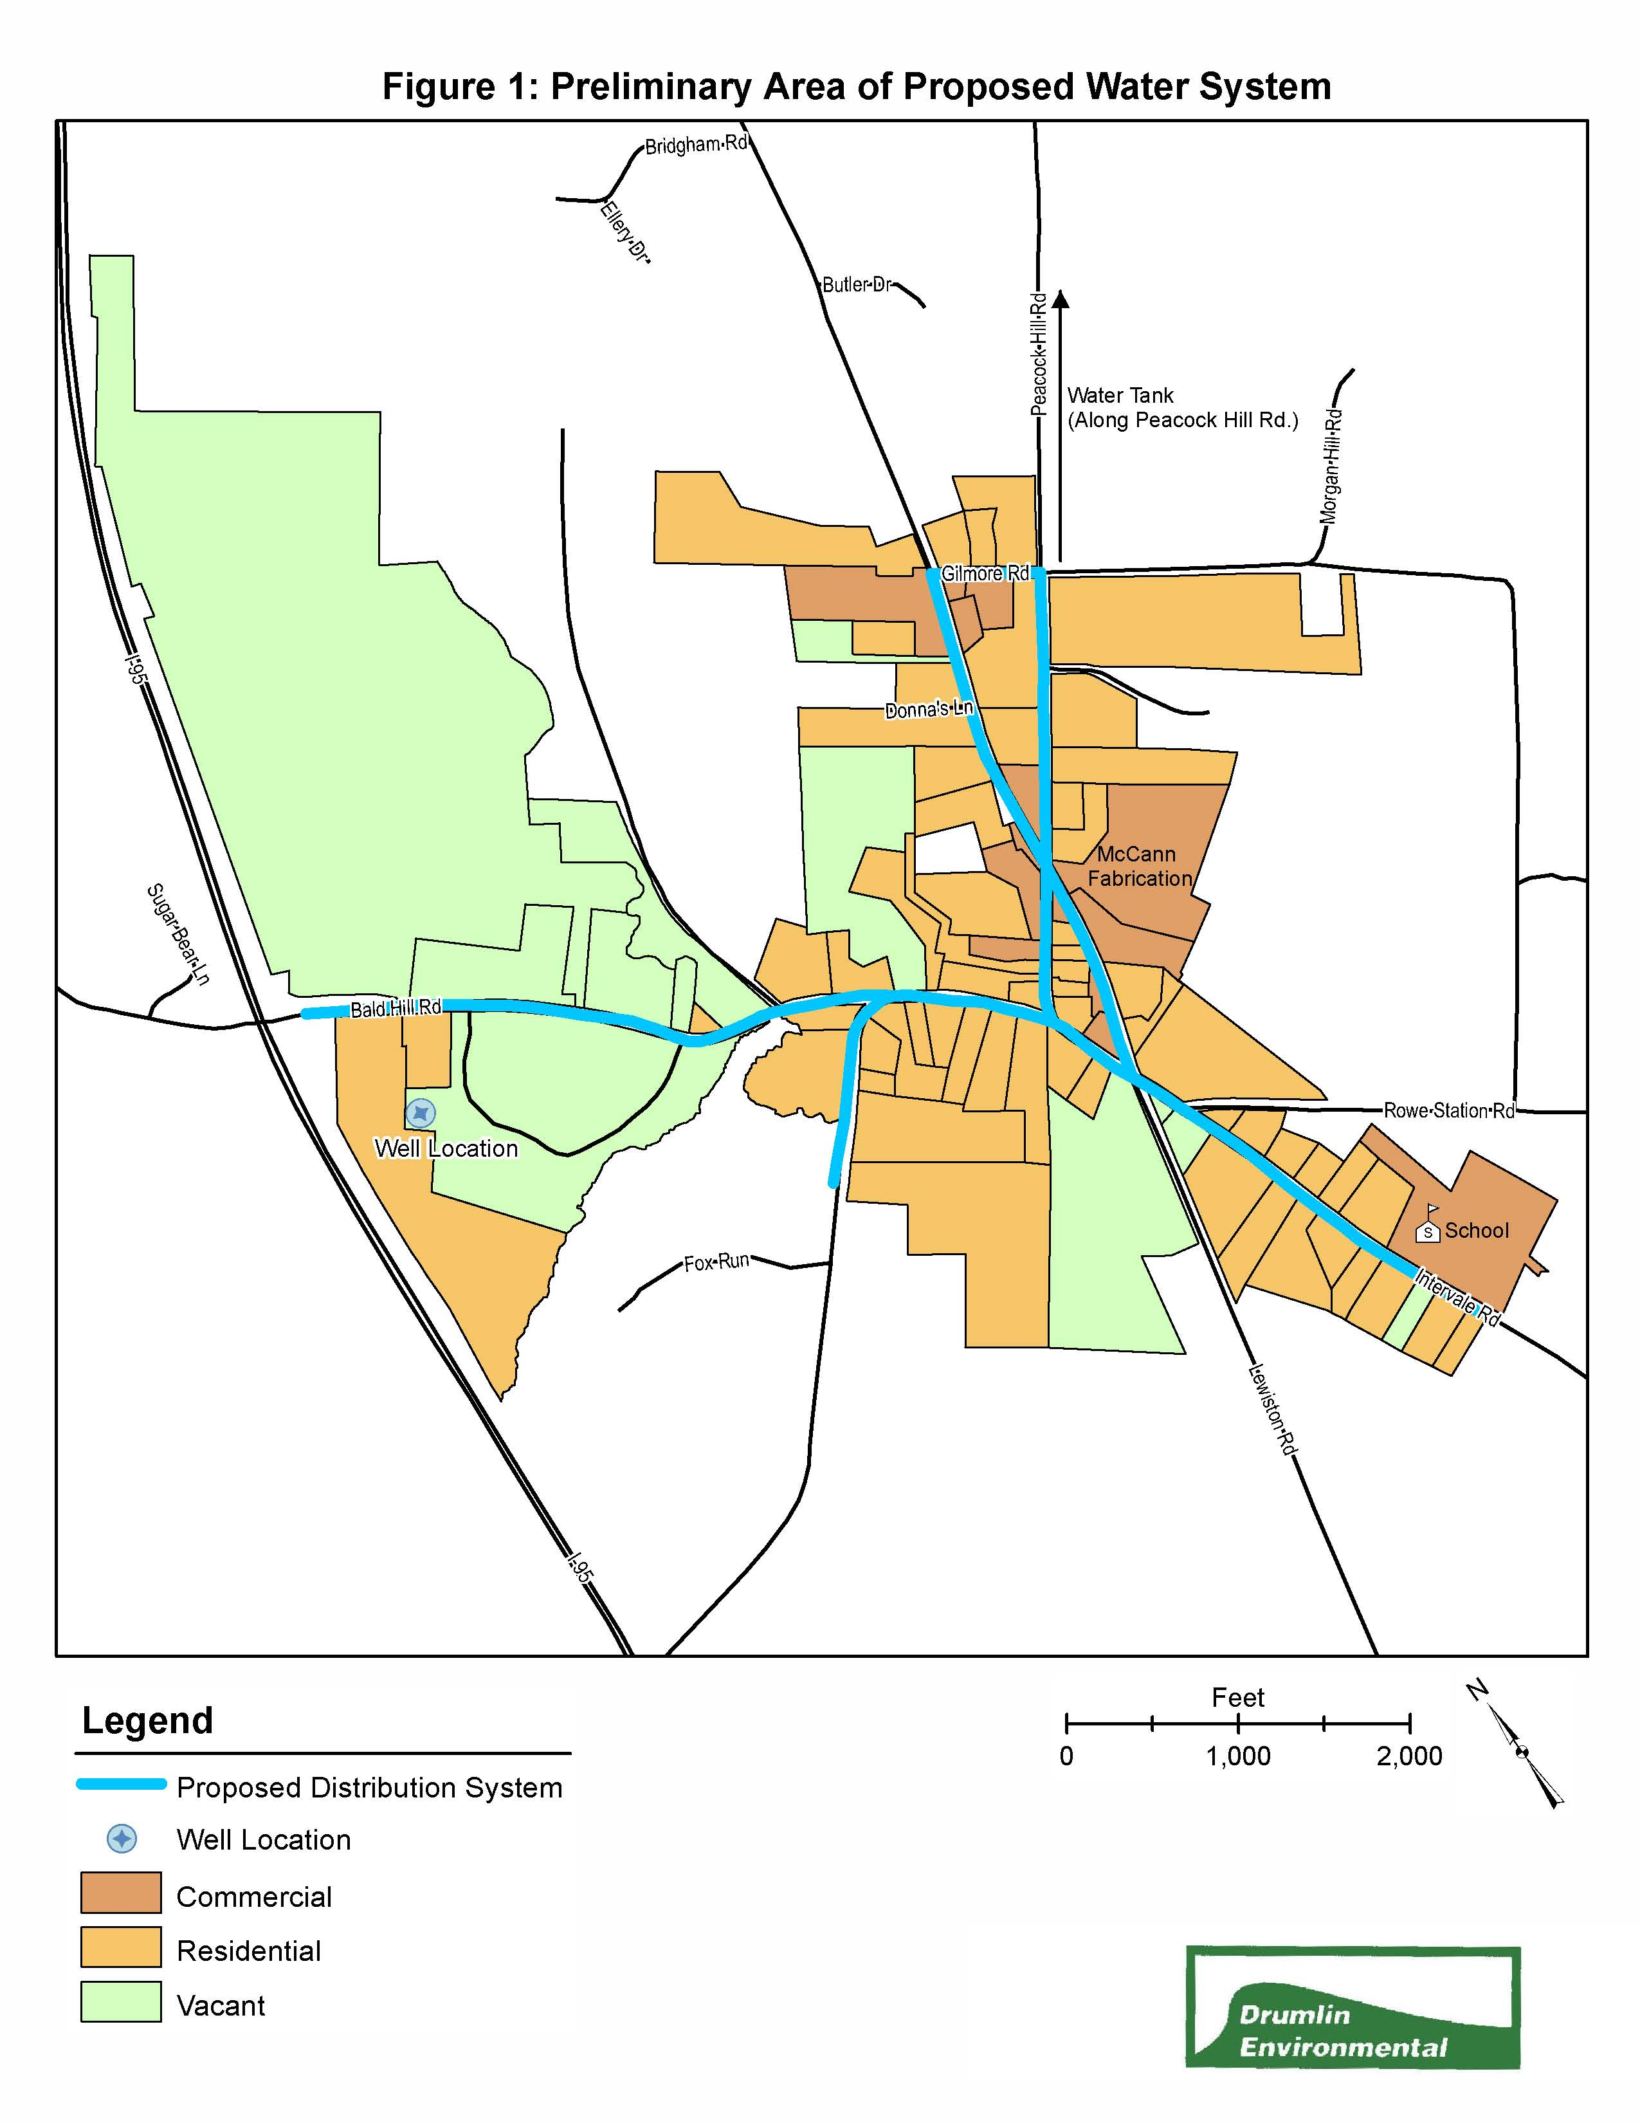

APPENDICES

APPENDIX A: WATER SYSTEM DEMAND ESTIMATE TABLE
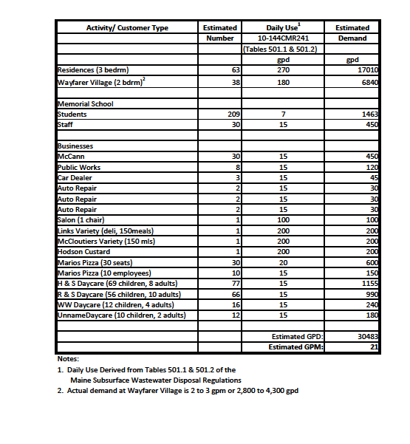
Lil’ Mart
Hodgman’s Custard

Map titled: Compiled Analytical Results; Maine DEP; Revised April 2009.
Letter correspondence; Chris Swain, ME DEP; May 15, 2009
DEP spill report file P-717-95
Contamination Assessment Report, Cloutiers Market; Field Services, inc; October 1994.
DEP spill report file P-558-92
Map titled: Compiled Analytical Results; Maine DEP; Revised April 2009.

