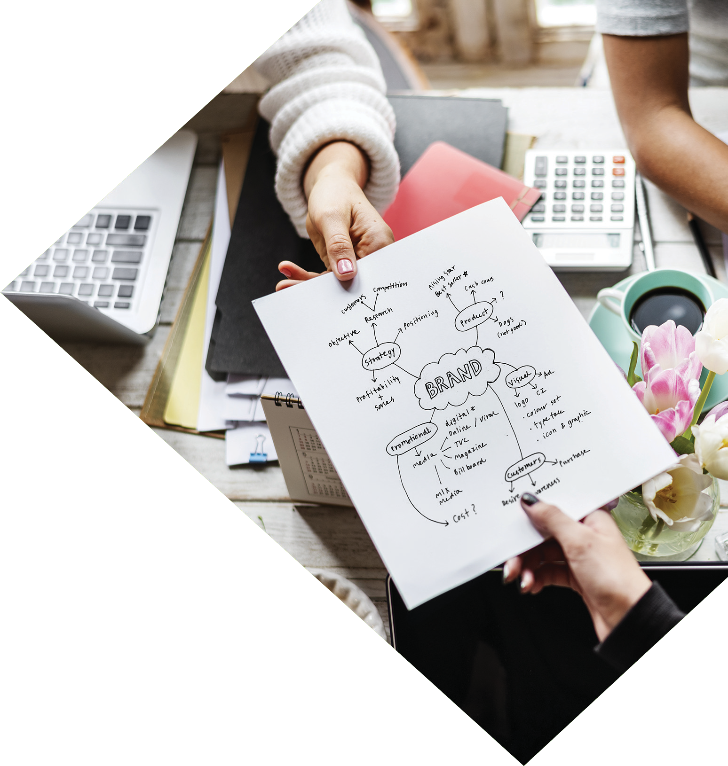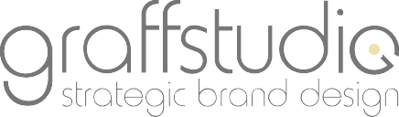

Creative Works 2007-2018

CREATIVE AGENCY

BROCHURE



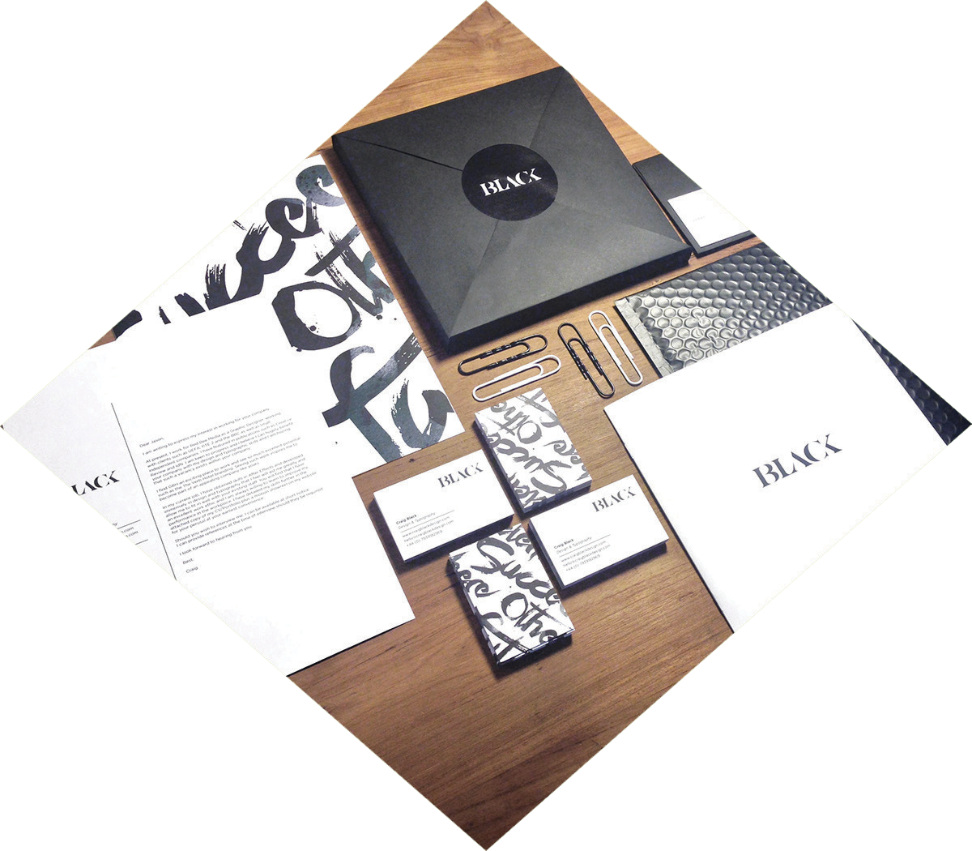

WHO ARE WE?

**Graﬀstudio Limited - is an internet market- ing agency operating across the British, the Scandinavian and Polish markets for over 11 years. With our help, dozens of entre- preneurs have acquired new clients and expanded their businesses.**

We care about the success of your business, your success

is our success. You can rely on us. That's why we ﬁnd proven marketing techniques that work for you. We help you gain a practical understanding of your customers’ needs and their expectations, which directly aﬀect the measurable end result.

WE PROVIDE TAILORED SOLUTIONS

We specialise in creating brand identity in digital and physical format. We provide a strong marketing service using appropriate tools. All of our projects stand out, and

are well planned and measurable.

The services we provide are distinguished by their high quality standards. Our knowledge of the industry and experience allows us to carry out multidimensional and integrated projects. We help promote your company and products with the help of the Internet, advertisement, marketing and packaging. Our team is experienced in brand strategy, design and development.We understand the importance of good management and the realisation

of projects.

**Jaroslaw Zeglen**

Creative Director



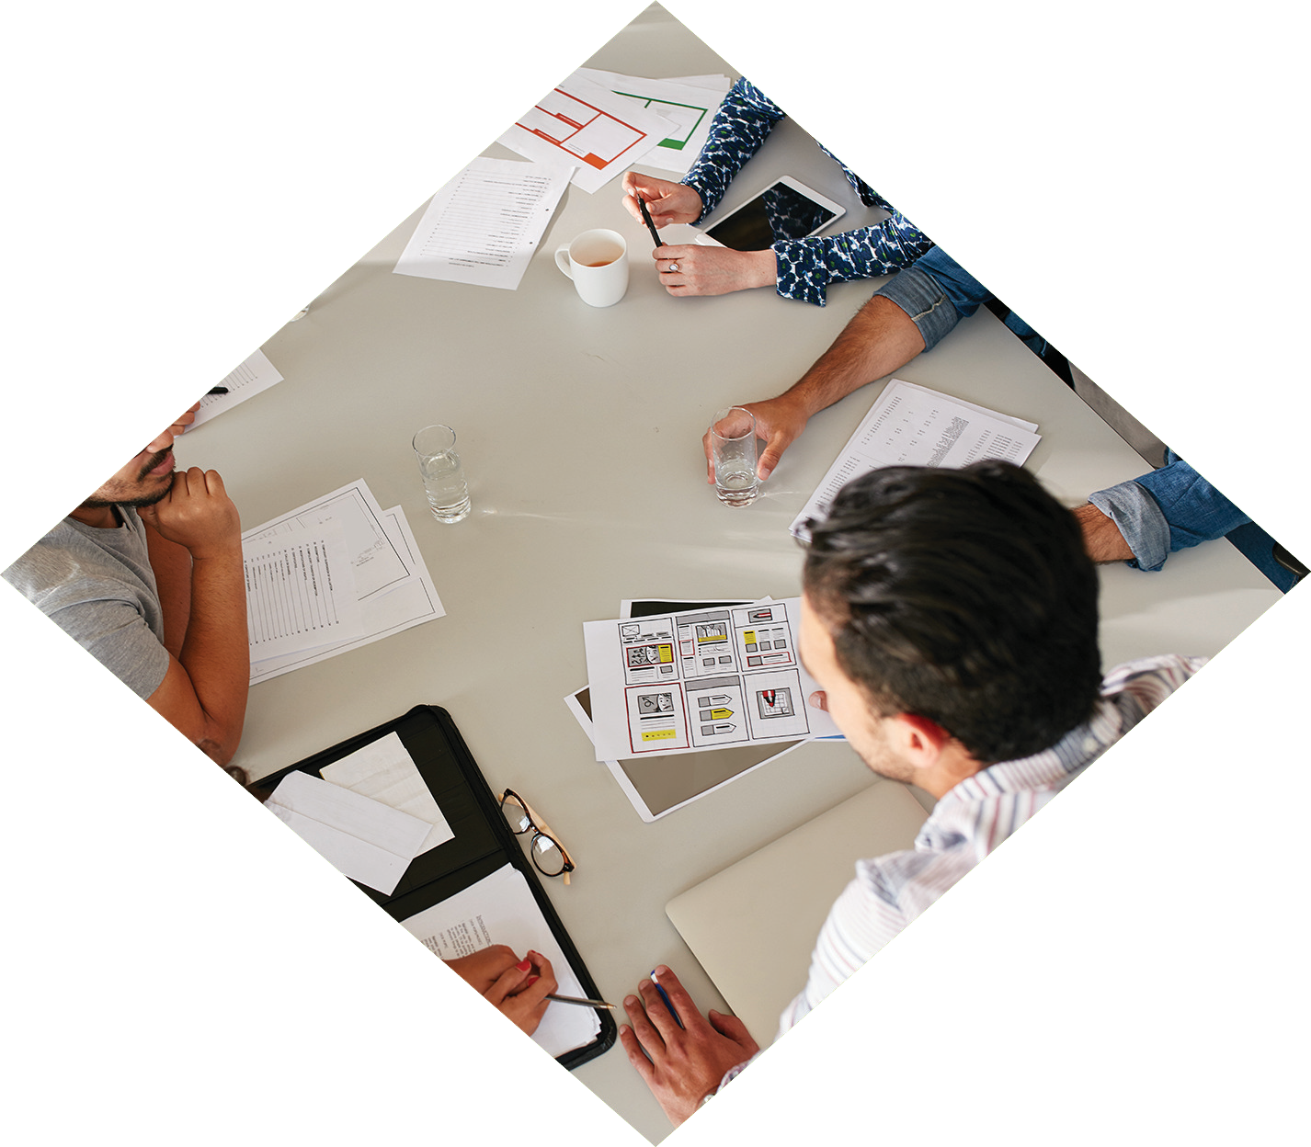

OUR SKILL, YOUR GROWTH

HOW WE WORK

We oﬀer a complex internet marketing service. Our oﬀer comprises of the most important and the most eﬀective marketing tools drawing from traditional, as well as our own, original solutions.

**Analysis**

We analyse your needs and expectations. We present you with the opportunities and beneﬁts to possessing a website, as well as other forms of advertising. We suggest the best solutions and we determine whether the Content Management System (CSM) is necessary in the context of your business.

**Graphical Concept**

Based on pre-established requirements, we proceed to the creation of the graphical concept. The concept encompasses all the elements which will not only distinguish your business, but will also draw in new clients. Throughout this process we continuously liaise with you, and aim to exceed your expectations.

**Finishing Touches**

We ensure the ﬁne details of the page are precise and there are no errors within the code. First, the website is launched under a test address, and then, with your approval, we place the website under the live domain. We integrate your social media and we oﬀer additional promotional services, for instance SEO Positioning in Google. Finally, you now have access to your ready-made website.





IDEAS THAT PROVOKE

VISUAL IDENTITY

We design modern visual identities which distinguish your company and your services from the competing brands. This is the basis for developing your corporate image and determines how potential clients will perceive your company. A distinct visual identity translates into an increase in positive relationships within and outside of the company, as well as your ﬁnancial proﬁt.

**Trademark-Logo**

The logo is important to expressing your company name and values. A well-designed logo is informa- tive, clearly signaling who you are within seconds of a glance. How you represent yourself and the impressions you receive, lays the foundations to building positive customer relations and developing their trust.

**Printing Services**

Thanks to our relations with the best printing service providers, we oﬀer you high quality printing services with support through each stage of the process: from the project, to the selection of technology and materials, through to the production and ﬁnancial planning.

**Websites**

We design modern websites, because we are aware that ﬁrst impressions count. You will not get another chance to make a good impression, therefore, if you do not have a functioning and modern website, many customers will leave after viewing it.

Remember: how your website appears determines whether a potential customer will want to establish a relationship with you.

**Online Stores**

We create online stores dedicated to and built on Open Source. An online store opens the gate to a new market, in which there are no boundaries. A well- designed system of online sales will allow you to maximize revenues and increase the number of your existing customers. The stores we create are attractive to potential clients, and are easy to navigate by the owner.

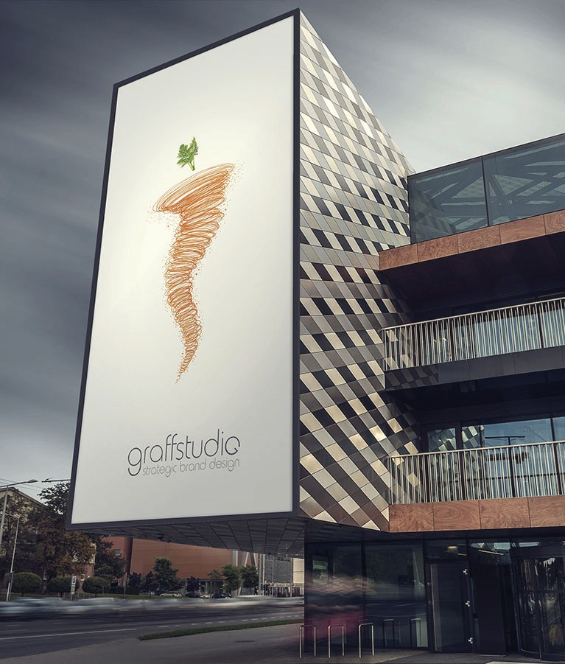

BUILDING BRANDS WITH PASSION

ONE BRILLIANT IDEA FOR EVERY CLIENT

Through our high-class techniques and bespoke growth plans, we assess digital problems and employ strategies that lead to commercial success.

**HIGH QUALITY**

Our main goal is to provide a consistent high level of service. By working closely with our customers and partners, we obtain the best results. We adapt customer expectations and their ﬁnancial capabilities to our estab- lished goals.

**OUR RESOLUTION**

At Graﬀstudio Limited we won’t simply build your website and run a digital marketing campaign. We create innovative solutions that allow your business to perform to its full potential.

**COOPERATION**

Thank you for your interest in Graﬀstudio Limited Begin- ning your cooperation with us is easy - just contact us by phone or leave us a message by e-mail using the contact form on our website or send it directly to [**enquiries@graﬀstudio.com**](mailto:enquiries@graﬀstudio.com) and we will contact you within one business day.

Through our high-class techniques and bespoke growth plans, we assess digital problems and employ strategies

that lead to commercial success.

This means reﬂecting what matters to you in our designs.

Whether that involves creating a phenomenal brand, a highly-optimised eCommerce website and a digital market-

ing strategy that delivers quality. We make it happen.

We push boundaries through thinking not just about your brand, your website, or your digital marketing – but how all of the digital elements of your business work together. It means thinking creatively about technology, and about the

technological impact of creative.

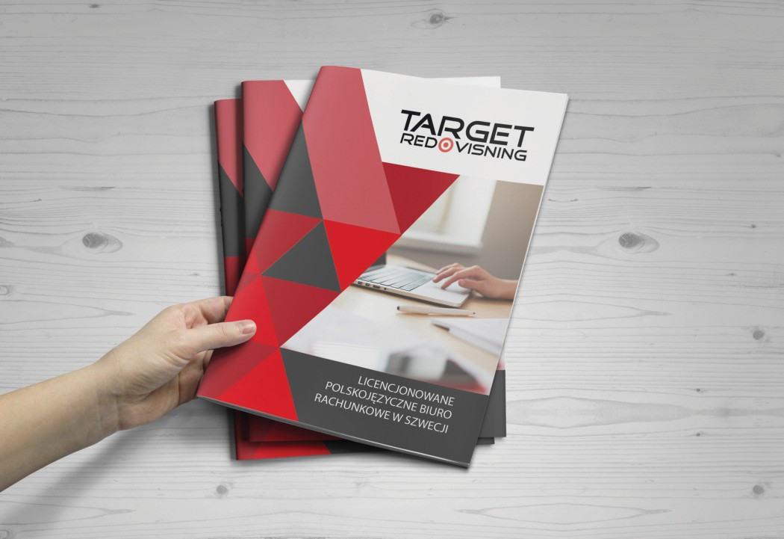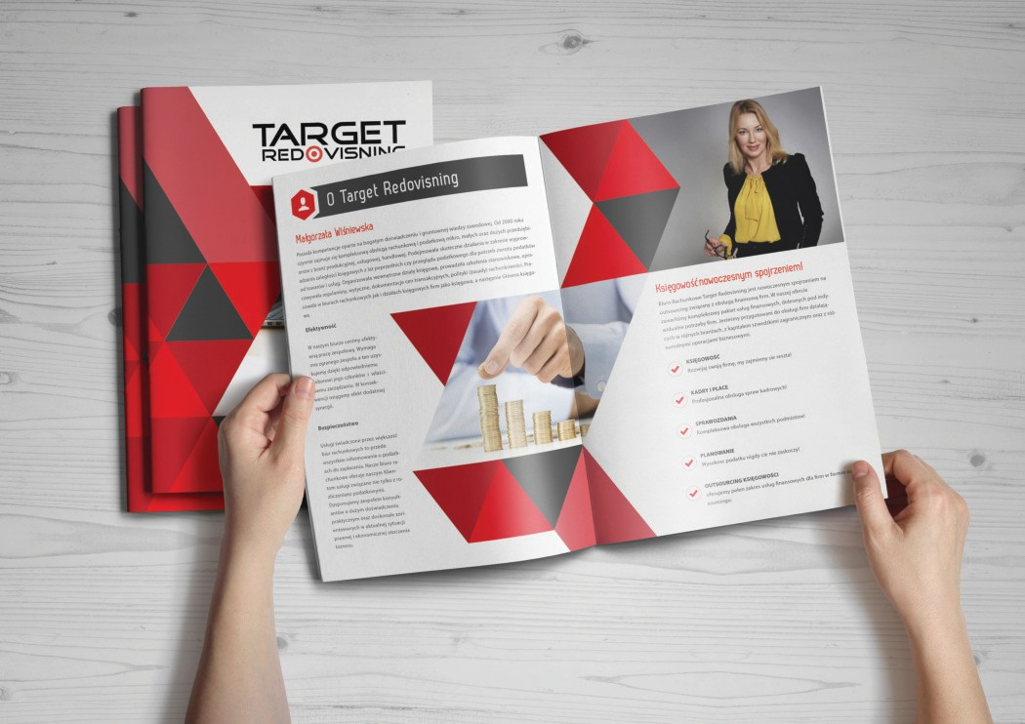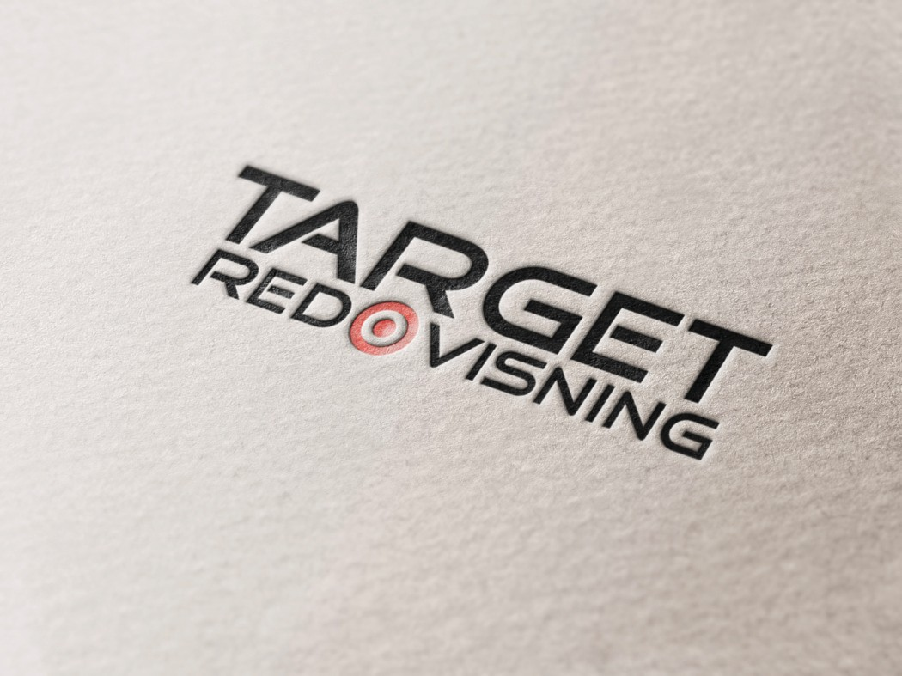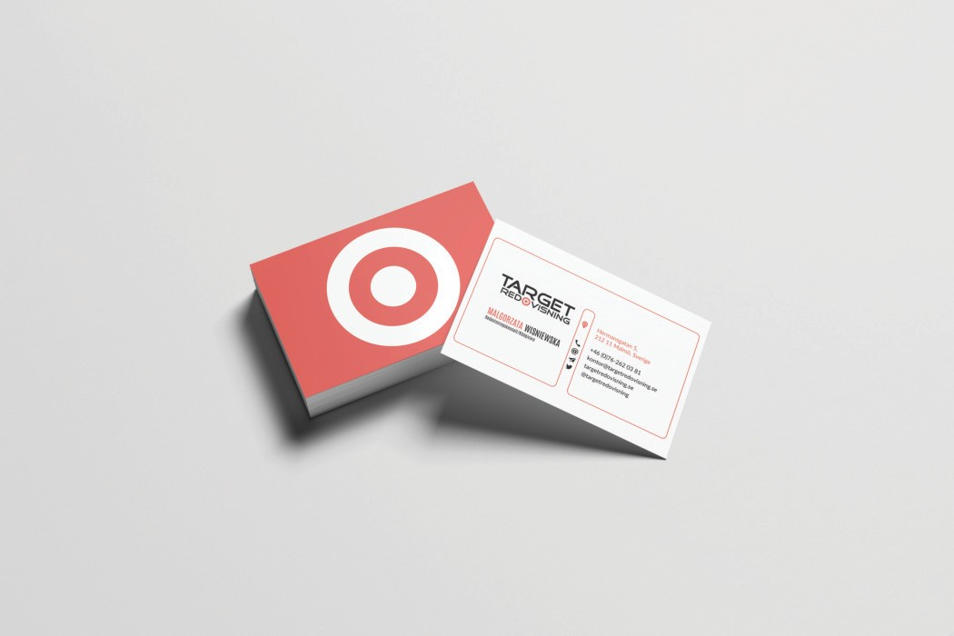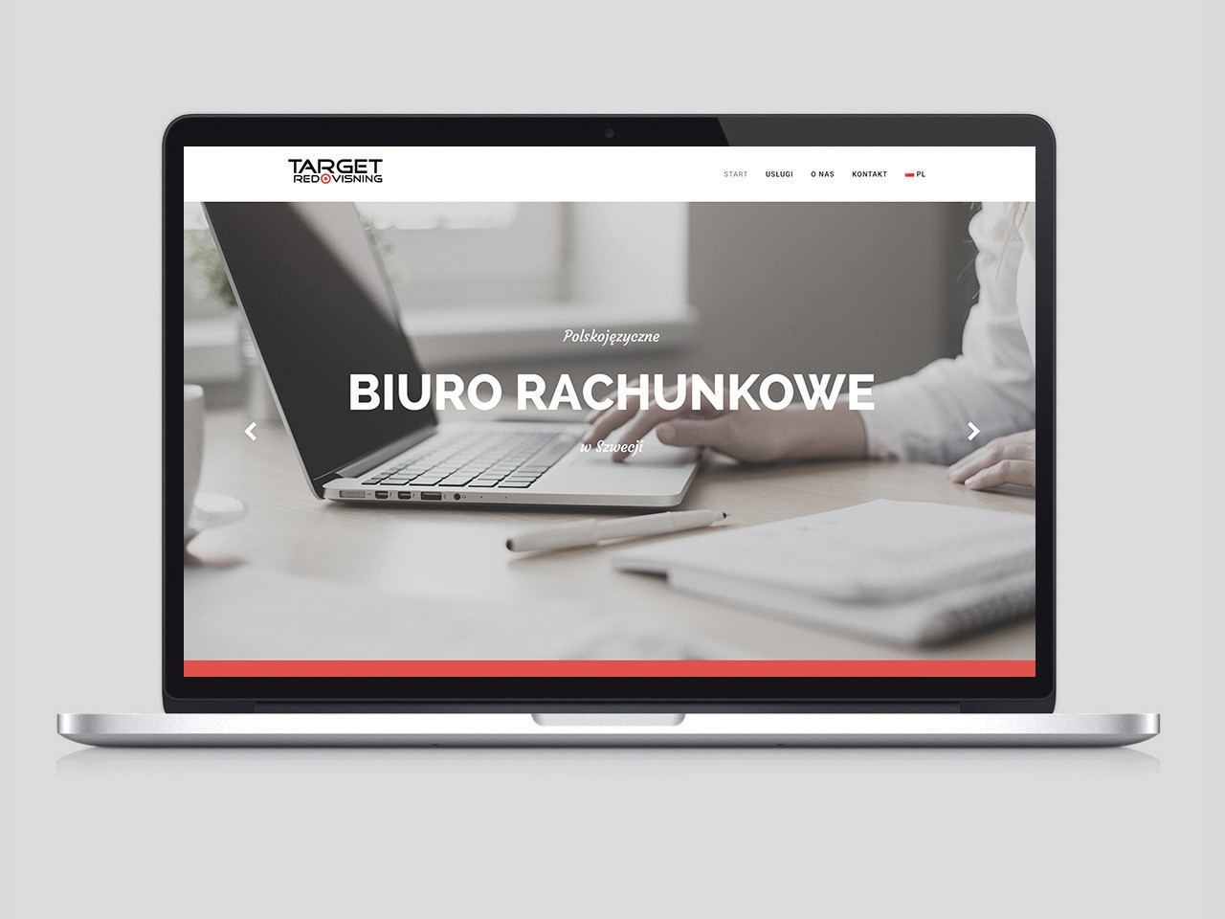

WHERE CREATIVITY MEETS TECHNOLOGY

FEATURED WORK

Our ultimate goal is to consistently provide a high level of service. By close co-operation with our customers and partners,

we get the best results. We closely match the expectations of our customers and their ﬁnancial capabilities to the objectives.

Having big ideas is one thing, but being able to deliver is something else. We value simplicity in our work because

we believe that the simple ideas are the most eﬀective. The

work may be complex, but if the idea is clear then the

details slot into place.

Graﬀstudio are much more than your average creative

agency. We’ve worked hard to earn recognition not only as a creative design studio but also as a top technology agency. Every one of our team is highly skilled and hard

working. To us, value means that you’re paying for the very

best creative services that you can get.

SEE MORE ON OUR WEBSITE

[www.graﬀstudio.com](http://www.graﬀstudio.com/)

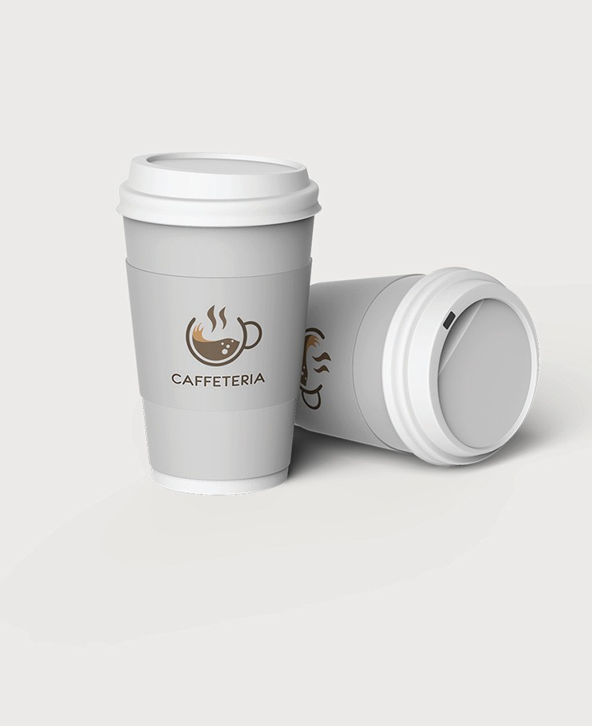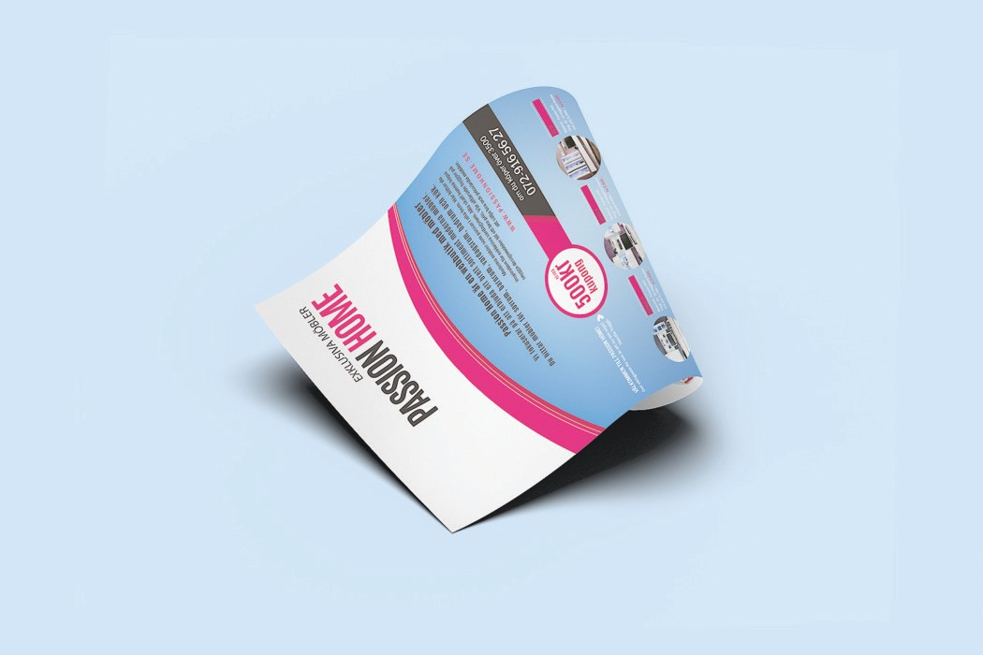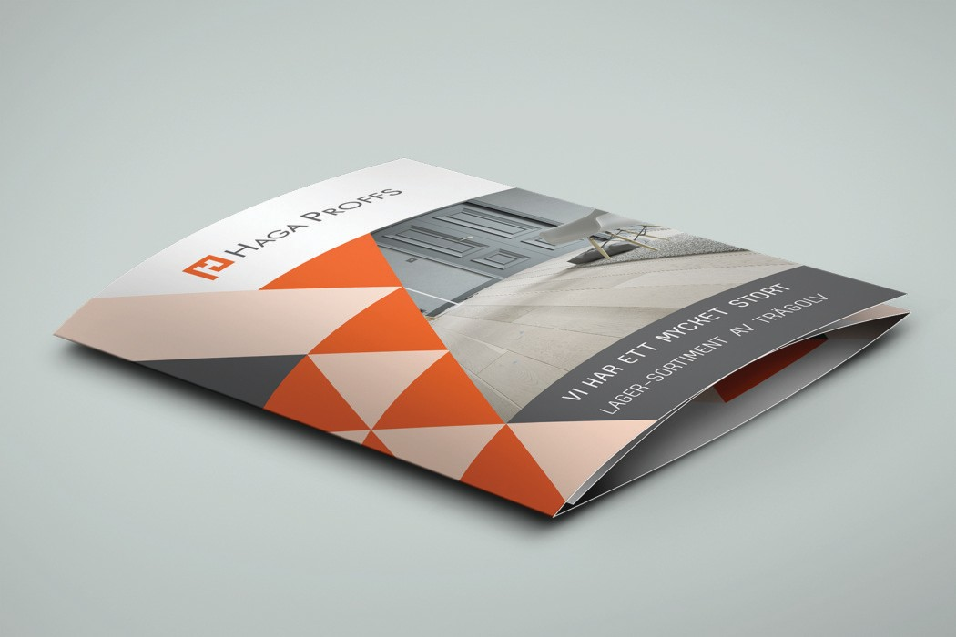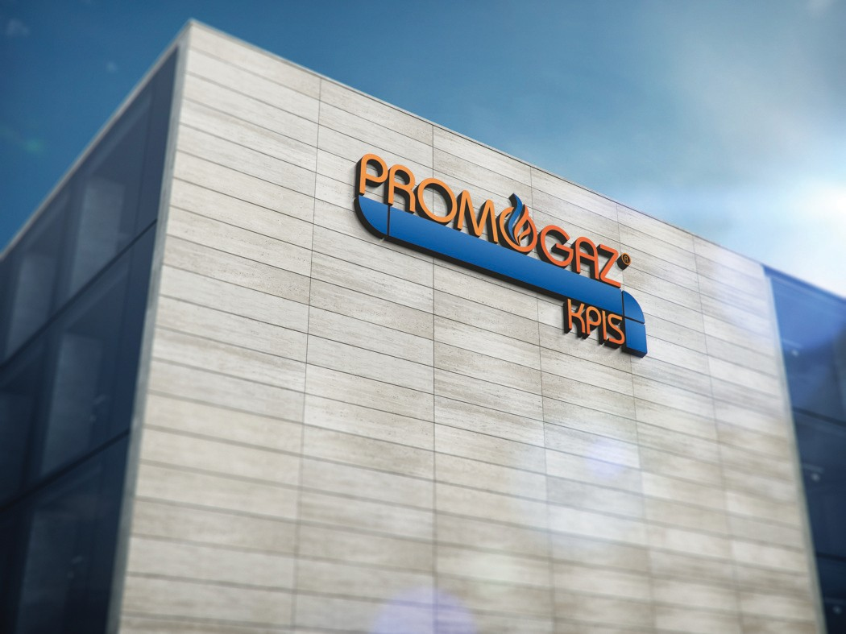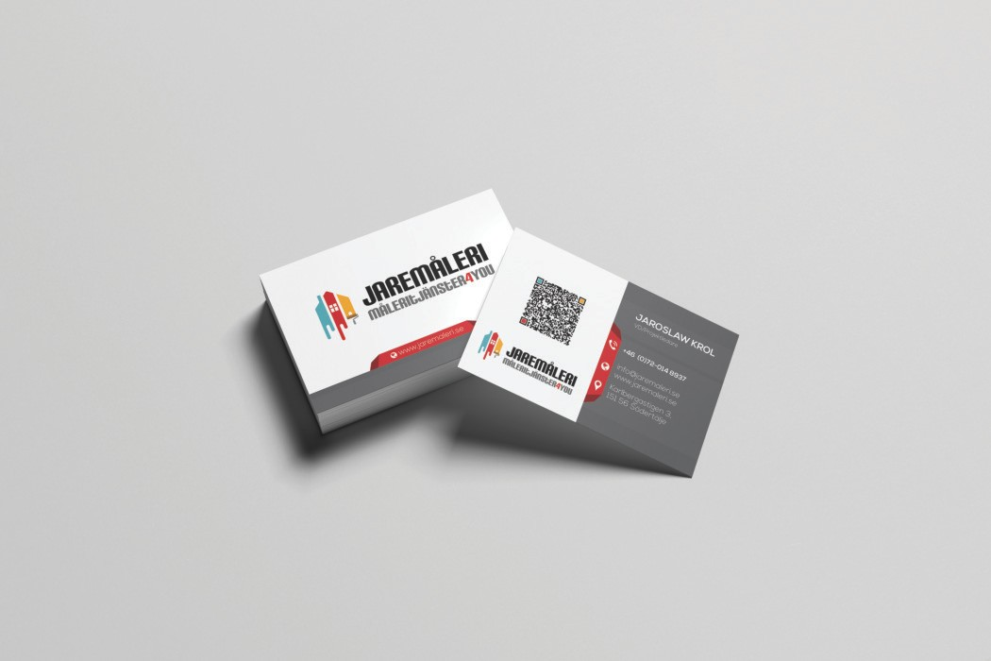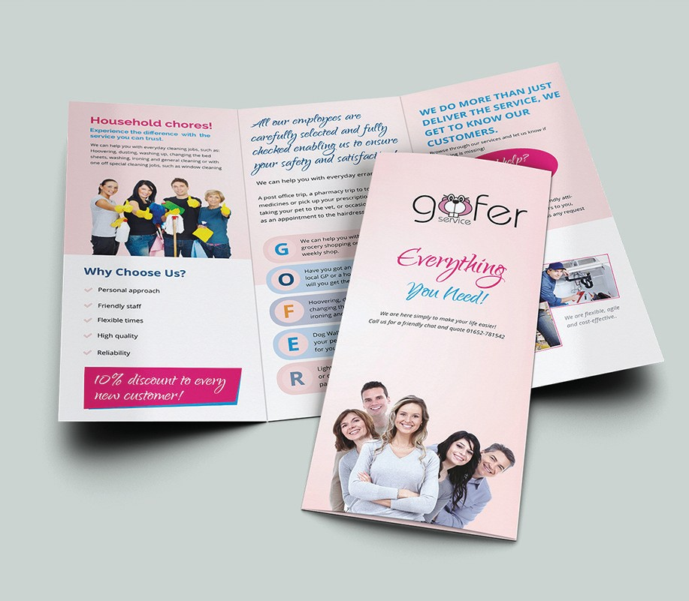

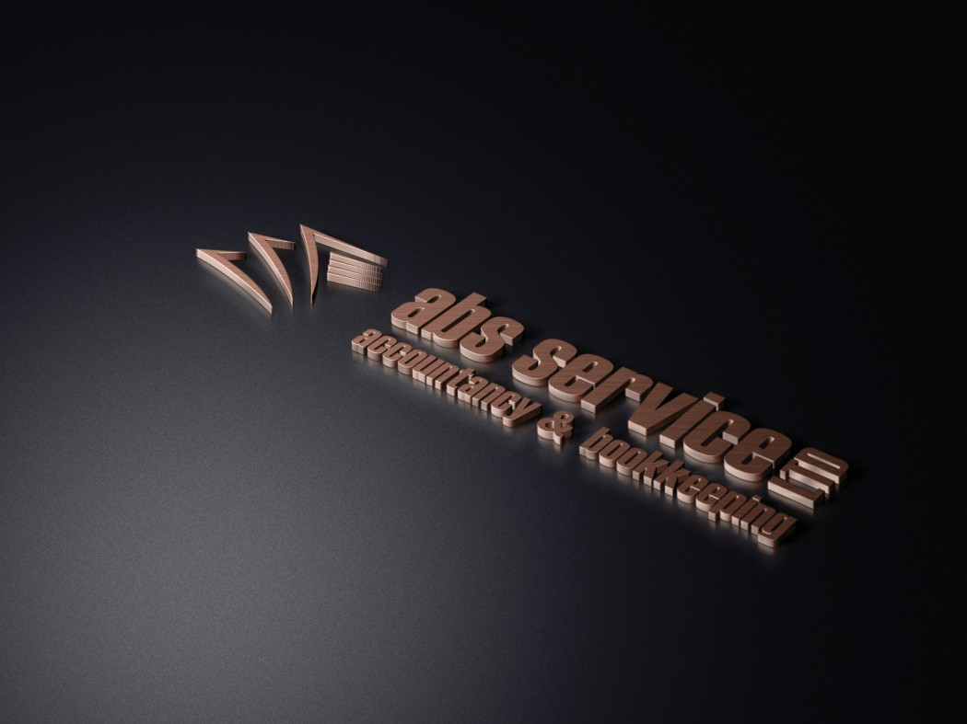

SEE MORE ON OUR WEBSITE

[www.graﬀstudio.com](http://www.graﬀstudio.com/)



PASSIONATE CREATIVE EXPERIENCED

BESPOKE PROGRESSIVE

INNOVATIVE

GRAFFSTUDIO LTD.

+44 (0) 7467-576636

+46 (0) 700-719919

+48 601-06 76 76

[office@graffstudio.com](mailto:office@graffstudio.com) [www.graffstudio.com](http://www.graffstudio.com/)