



muslin.biz

ISO9001:2015

OEKO-TEX R

Certified

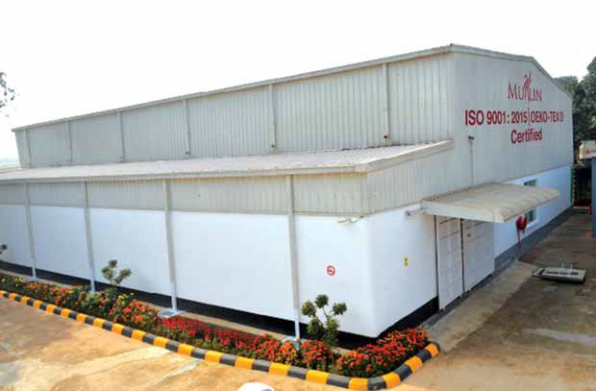

Who are we?

ABOUT MUSLIN

The "Muslin" is the greatest part of our glorious history. It was so popular to Roman Ladies in ancient Rome that an ounce of muslin used to sell in Rome for an ounce of gold! During the 17th and 18th centuries, Mughal Bengal emerged as the foremost muslin exporter in the world, with Mughal Dhaka as capital of the worldwide muslin trade.

This is a 100% export oriented garments accessories manufactur- ing company. At present, we have started production with garments accessories and will expand service areas in fashion industry. We also do package support for all sorts of accessories. Muslin is dedicated to

ensure best

quality

products,

in-time delivery and competitive price. We are fully concern with quality service and we will ensure MUSLIN QUALITY in all aspects of service.

Muslin

Fashions

Ltd.

is the

manufacturer of accessories for fashion items with the quality and brand image of ancient Muslin

Cloths. Muslin Fashions Ltd. is a limited company incorporated under Company Act.

**Muslin Fashions Ltd. is an ISO 9001: 2015 certified company**

**Muslin is the symbol of Quality and Pride.**



Muslin Slogan

Perfect to Serve

2 [info@muslin.biz](mailto:info@muslin.biz) +88 04478035946-7 [www.muslin.biz](http://www.muslin.biz/)

VISION

Making a Global Brand

MISSION

We will make major changes to the fashion industry to make a Global Brand from Bangladesh creating positive image by providing best quality products and best services to the world community. We have started from the ground to reach the Top.





WE ARE ACCREDITED

iso 9001: 2015

OEKO-TEX R

[info@muslin.biz](mailto:info@muslin.biz) +88 04478035946-7 [www.muslin.biz](http://www.muslin.biz/) 3

**Eco-friendly Factory**

according to Oeko-Tex R Standard 100



Markets We Serve

Garments Industry

We provide best support to the 100% Export Oriented Ready Made Garments Industry. We provide the right thing at right time. We keep our eyes on the time of delivery to enhance buyer's confidence on our valued clients.

Accessories Industry

We also open our hands to our friends who are working in the same industry so that they can offer best support to their clients. The Suppliers are always welcomed to us and we provide the in-time support with the best price.

4 [info@muslin.biz](mailto:info@muslin.biz) +88 04478035946-7 [www.muslin.biz](http://www.muslin.biz/)



MUSLIN STANDARD

**JIT**

**Delivery**

**BEST QUALITY PRODUCTS**

**COMPETITIVE PRICE**

**MUSLIN**

**STANDARD**

BEST QUALITY PRODUCTS

Muslin is the symbol of Quality. All of our products are made by confirming to our strict quality standards. All services are performed following or exceeding all Quality Standards. To achieve the Best Quality, we use:

•

Best quality raw materials imported from Thailand, Taiwan and Korea.

Modern Machineries having latest technological advancements Properly trained, motivated and skilled manpower

IT system controlled production management system following Good Manufacturing Practices (GMF)

Total Quality Management (TQM) system for inventory, production and supply.

•

•

•

•

**Thus, we are Perfect to Serve you with the best quality product.**

[info@muslin.biz](mailto:info@muslin.biz) +88 04478035946, +88 04478035947 [www.muslin.biz](http://www.muslin.biz/) 5



JUST-IN-TIME DELIVERY

We follow Just-In-Time (JIT) inventory delivery strategy so that our valued clients can reduce their burden of inventory management. We can supply within very short period of time and thus our clients can manage the emergencies without taking any risk. We follow JIT supply chain management system and use our own delivery vans. We are able to deliver goods to Dhaka and Chittagong City area at day-time by our special vans manufactured by following traffic rules.

We are Just-In-Time. The world's worst traffic congestions in Dhaka city can't stop our JIT Delivery!

Thus, we are **Perfect to Serve** you with the best quality service!

COMPETITIVE PRICE

We offer the possible best price to our clients which is very much competi- tive in the market without compromising Quality of product and service. We follow the following philosophy to reduce the cost of goods:

* Obtaining all legal benefits provided by Government for the 100% export oriented industry
* We maintain the strong Just-In-Time (JIT) supply chain system to reduce the higher inventory cost
* We develop highly skilled workforce to get maximum productivity
* We use the best quality machineries and raw materials, and uninterrupted power supply to reduce wastage
* We use low cost credit facilities to reduce the high interest burden

We make profit by reducing cost of production , not from sales. Thus, we are

**Perfect to Serve** you with the best price!

6 [info@muslin.biz](mailto:info@muslin.biz) +88 04478035946-7 [www.muslin.biz](http://www.muslin.biz/)

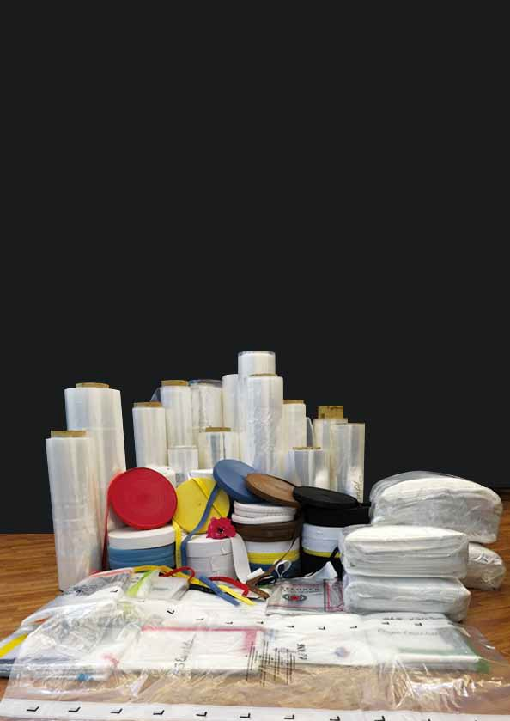

Muslin

Products

[info@muslin.biz](mailto:info@muslin.biz) +88 04478035946-7 [www.muslin.biz](http://www.muslin.biz/) 7

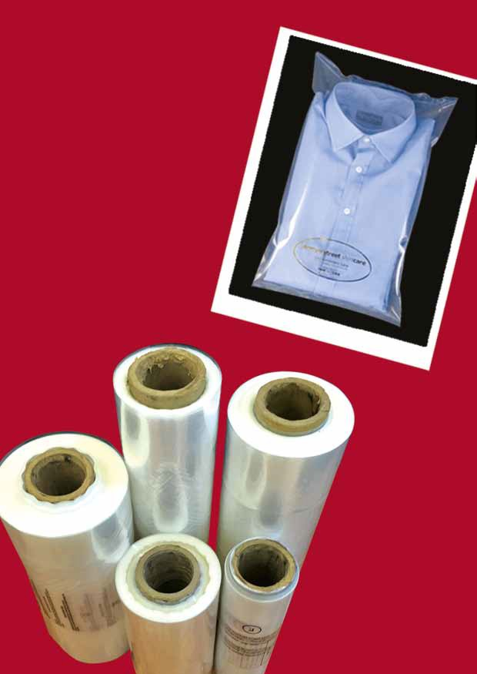

PP Bags

PP/LDPE in Roll

8 [info@muslin.biz](mailto:info@muslin.biz) +88 04478035946-7 [www.muslin.biz](http://www.muslin.biz/)

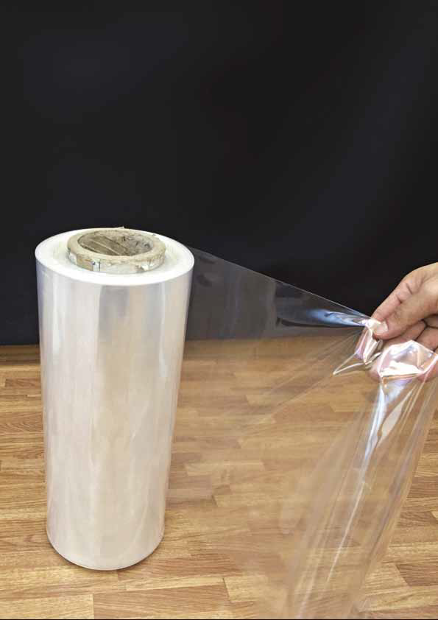

PP FILMS

[info@muslin.biz](mailto:info@muslin.biz) +88 04478035946-7 [www.muslin.biz](http://www.muslin.biz/) 9

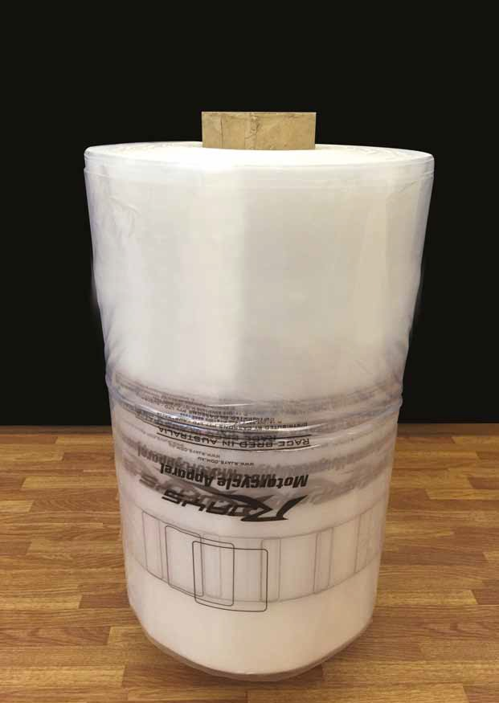

PP FILMS

10 [info@muslin.biz](mailto:info@muslin.biz) +88 04478035946-7 [www.muslin.biz](http://www.muslin.biz/)

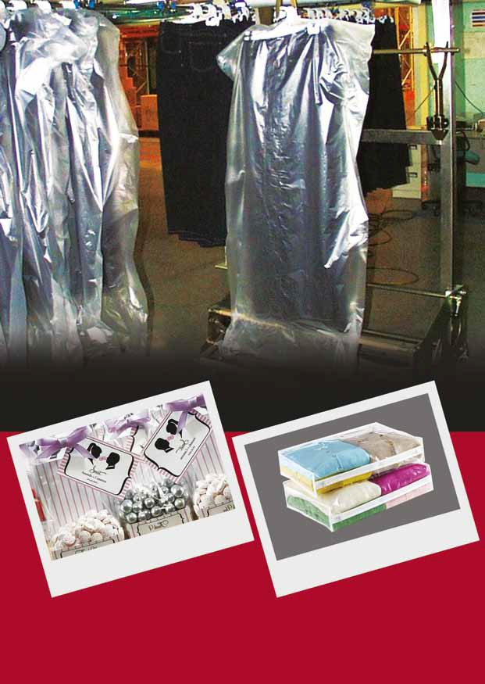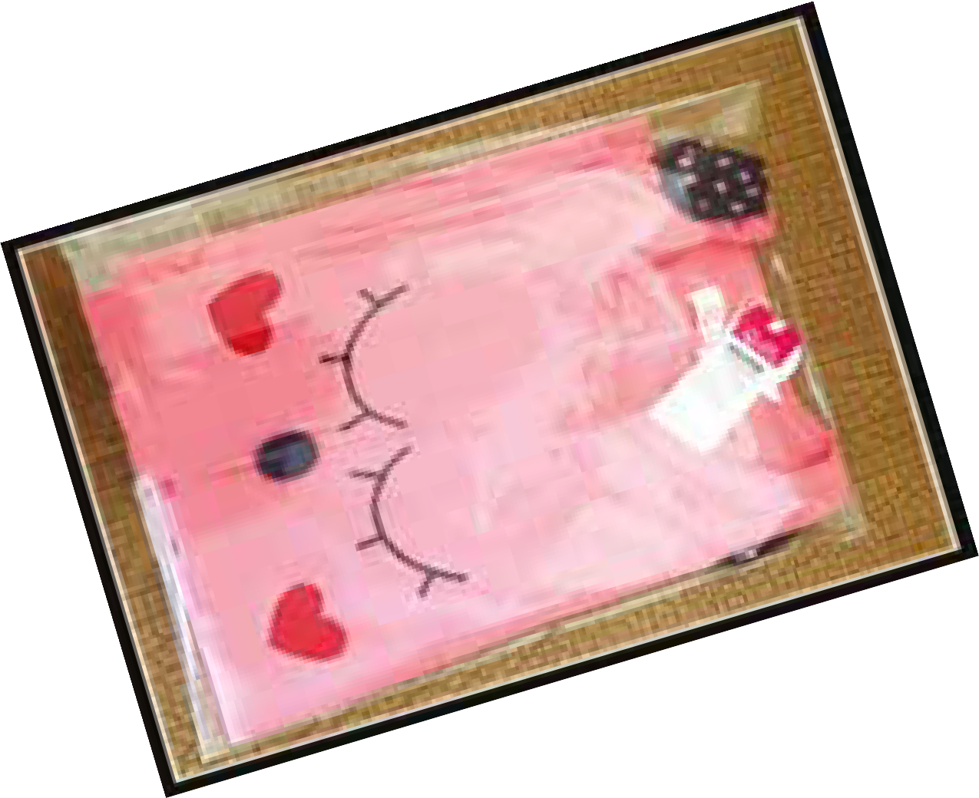

OUR PRODUCT IN DISPLAY at Store

[info@muslin.biz](mailto:info@muslin.biz) +88 04478035946-7 [www.muslin.biz](http://www.muslin.biz/) 11

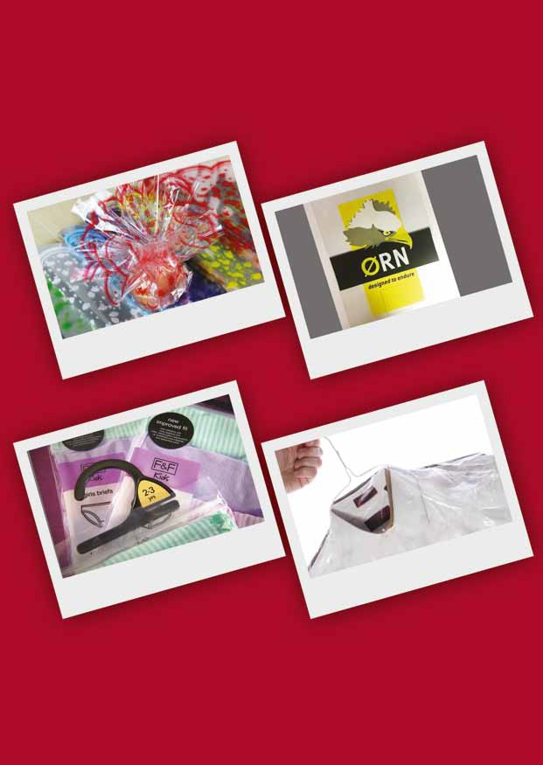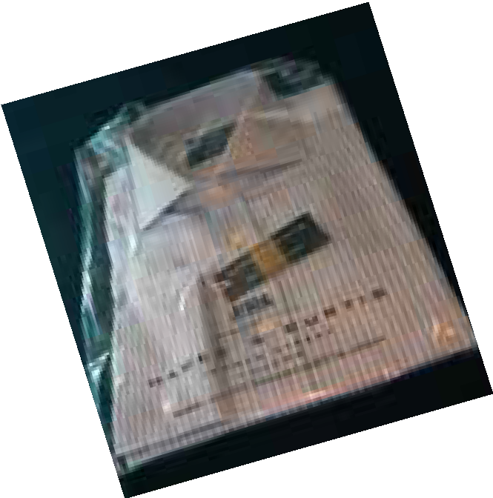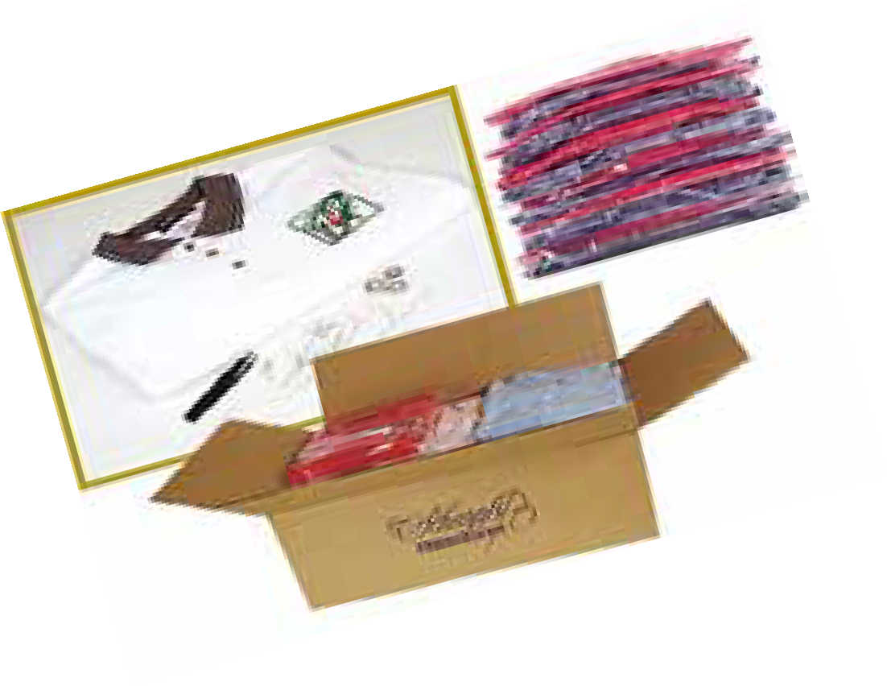

PRINTED

POLY BAGS

12 [info@muslin.biz](mailto:info@muslin.biz) +88 04478035946-7 [www.muslin.biz](http://www.muslin.biz/)

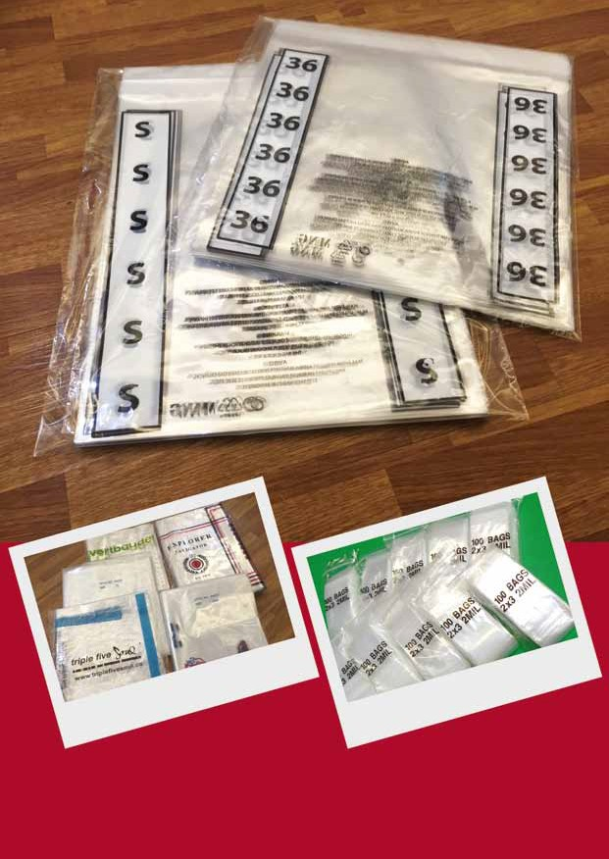

PRINTED

POLY BAGS

[info@muslin.biz](mailto:info@muslin.biz) +88 04478035946-7 [www.muslin.biz](http://www.muslin.biz/) 13

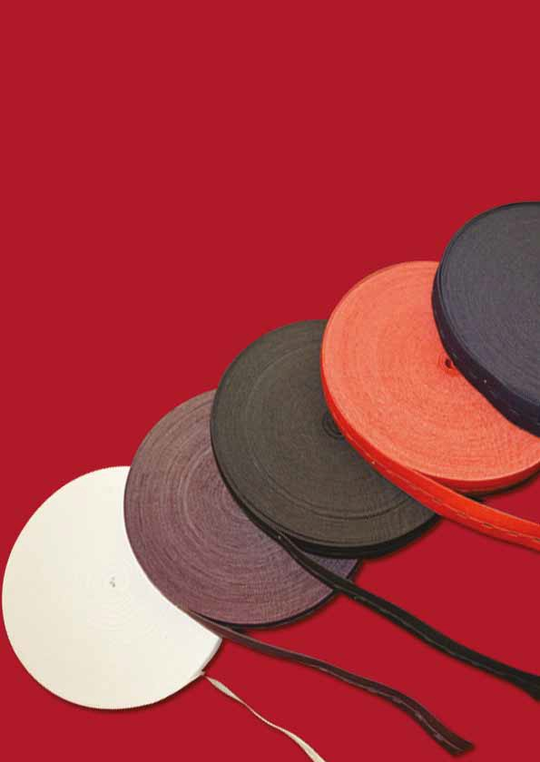

Elastic Bands

14 [info@muslin.biz](mailto:info@muslin.biz) +88 04478035946-7 [www.muslin.biz](http://www.muslin.biz/)

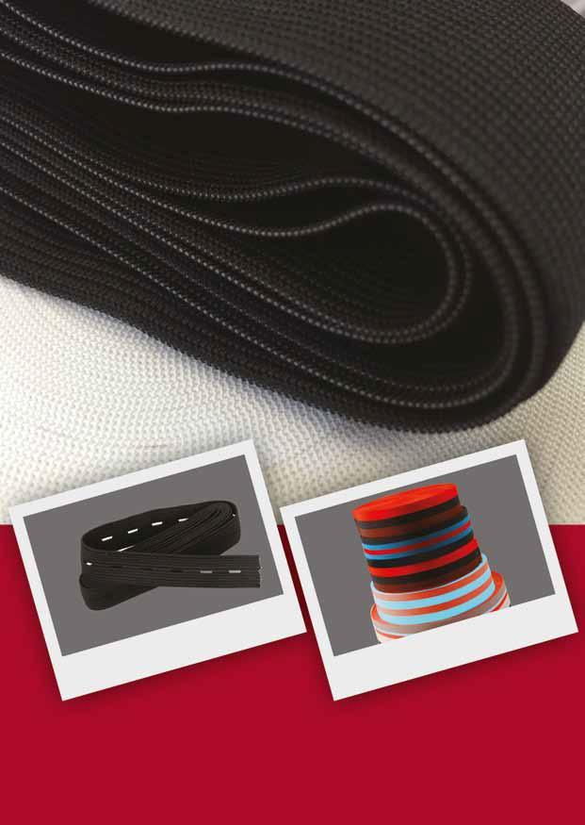

Elastic Bands

[info@muslin.biz](mailto:info@muslin.biz) +88 04478035946-7 [www.muslin.biz](http://www.muslin.biz/) 15

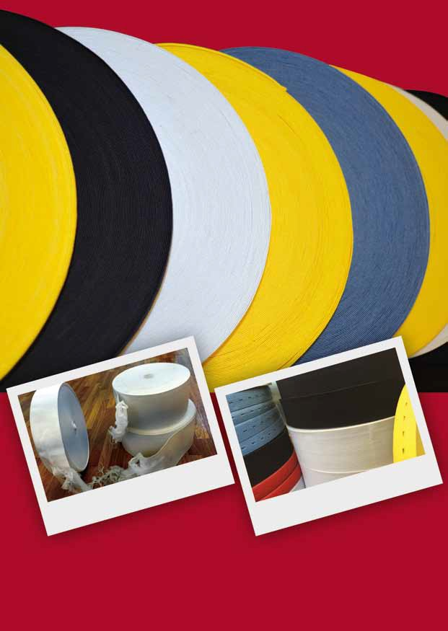

Elastic Bands

16 [info@muslin.biz](mailto:info@muslin.biz) +88 04478035946-7 [www.muslin.biz](http://www.muslin.biz/)

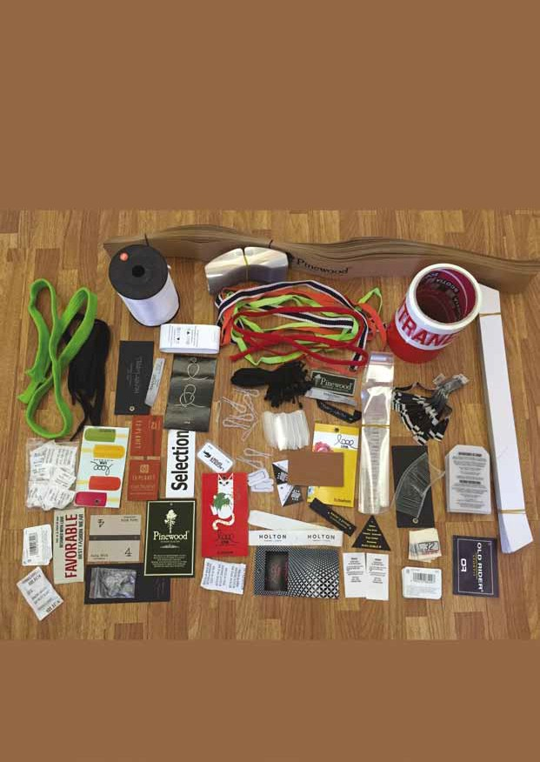

Package Support

[info@muslin.biz](mailto:info@muslin.biz) +88 04478035946-7 [www.muslin.biz](http://www.muslin.biz/) 17



Package Support

Besides our manufacturing products, we also provide package supply service to our valued clients so that they have not to deal with numerous suppliers. For all or our supply, either manufactured in our factory of sourced from our colleague's factories, we follow the MUSLIN STANDARDS.

We produce accessories under the package supply service in the manufac- turing units of our fellow colleagues who has very good business records and are maintaining quality and commitments. We are used to supply the following accessories in regular basis.

18 [info@muslin.biz](mailto:info@muslin.biz) +88 04478035946-7 [www.muslin.biz](http://www.muslin.biz/)

**Neck board Collar stand Butterfly Tissue paper Ballpin Brasspin Plastic pin Plastic clip Silica gel Printed tape Inner carton Master carton**

**Woven label Printed label Sewing label Elastic thread Button Jacquard Elastic Hang tag**

**Price tag Barcode sticker Price sticker Photo card Back board**

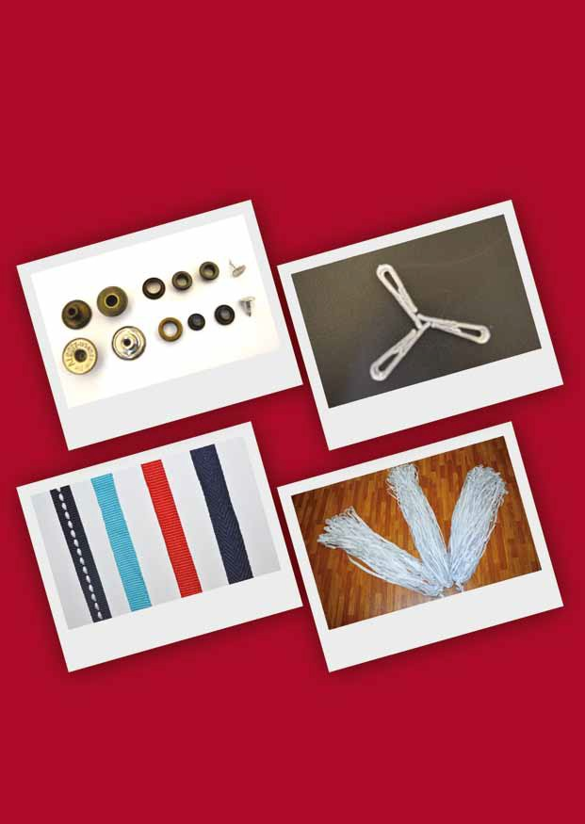

Package Support

[info@muslin.biz](mailto:info@muslin.biz) +88 04478035946-7 [www.muslin.biz](http://www.muslin.biz/) 19

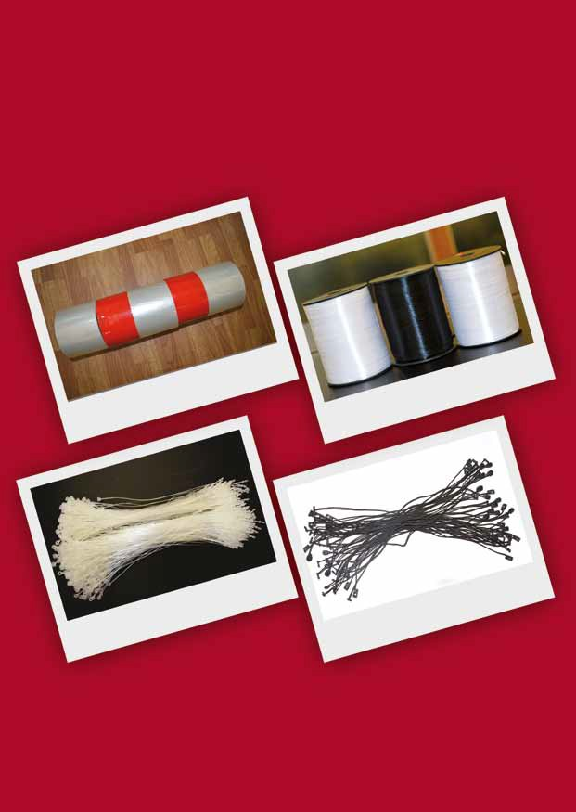

Package Support

20 [info@muslin.biz](mailto:info@muslin.biz) +88 04478035946-7 [www.muslin.biz](http://www.muslin.biz/)

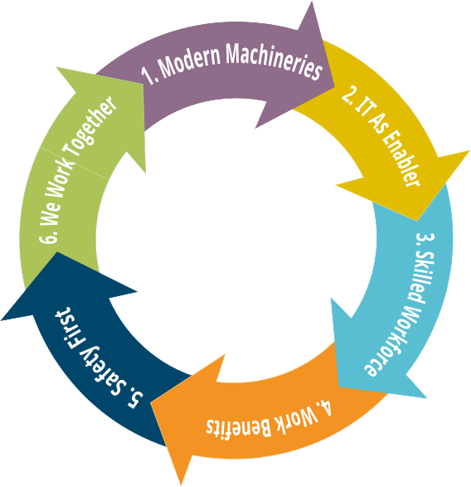

**WAYS WE WORK**

[info@muslin.biz](mailto:info@muslin.biz) +88 04478035946-7 [www.muslin.biz](http://www.muslin.biz/) 21

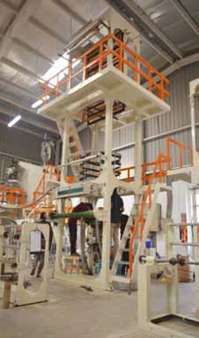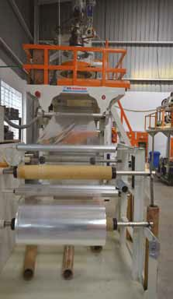

**MODERN MACHINERIES**

We use all brand new modern machineries imported from Taiwan. All blowing machines (LLDPE/PP/HDPE) have all modern facilities to produce best quality products. All machines are of the power saving quality to save electricity and are environment friendly. Quantity: 4

22 [info@muslin.biz](mailto:info@muslin.biz) +88 04478035946-7 [www.muslin.biz](http://www.muslin.biz/)

**PP Blowing Machine**

**LD Blowing Machine**

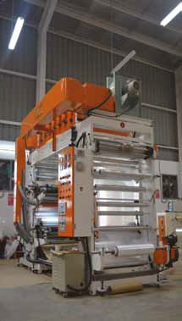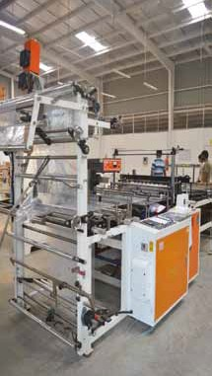

**MODERN MACHINERIES**

All printing machines are brand new and imported from Taiwan. All print- ing machines have all modern facilities to produce best quality print.

Quantity: 4. Colour: 4/2

All cutting machines are brand new and imported from Taiwan having modern facilities to produce best quality product. Quantity: 2

[info@muslin.biz](mailto:info@muslin.biz) +88 04478035946-7 [www.muslin.biz](http://www.muslin.biz/) 23

**CUTTING Machine**

**Printing Machine**

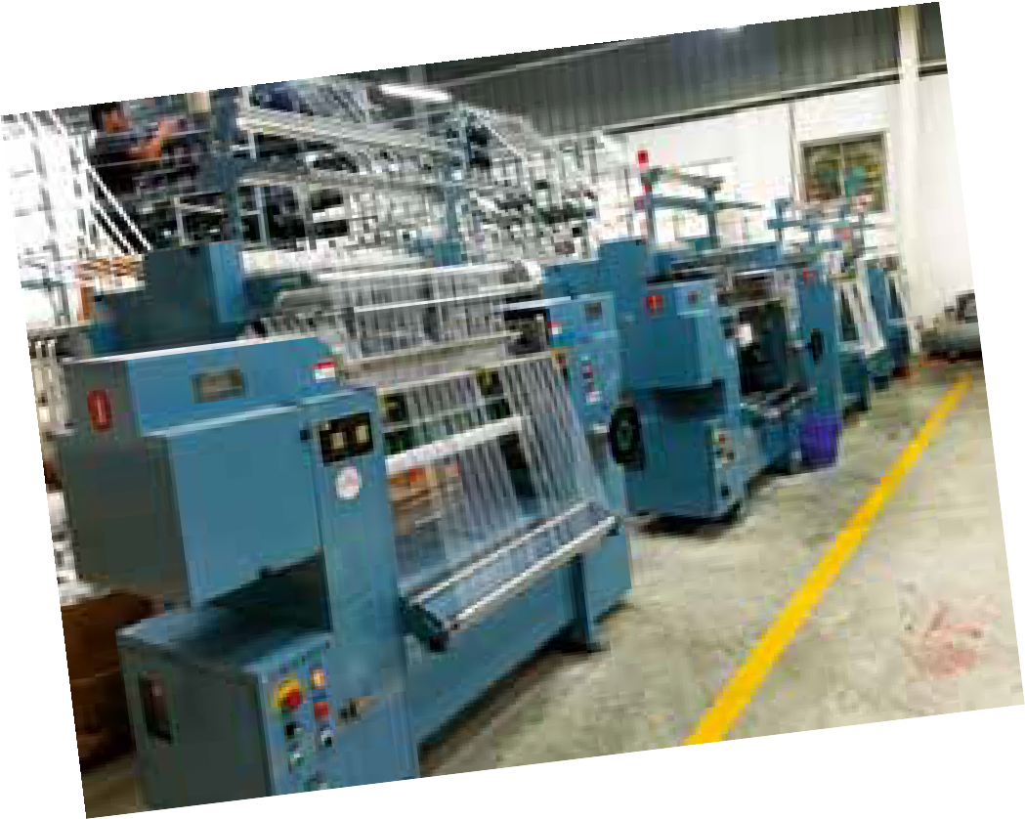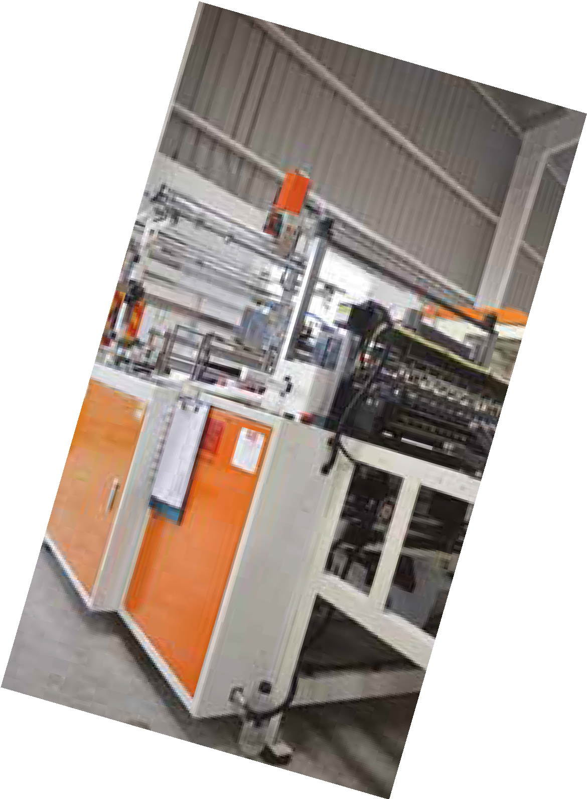

**MODERN MACHINERIES**

24 [info@muslin.biz](mailto:info@muslin.biz) +88 04478035946-7 [www.muslin.biz](http://www.muslin.biz/)



[www.muslin.biz](http://www.muslin.biz/)

[info@muslin.biz](mailto:info@muslin.biz)

+88 04478035946-7

25



Skilled Workforce

A skilled workforce is the key to growing a business in a saturated market. It gives leverage a business to win the race in a very competitive market like ours. A skilled workforce is among the most important attribute of a company. A skilled worker is a worker who has special skill, training, knowledge, and acquired ability in their work.

Skills development enhances both people’s capacities to work and their opportunities at work, offering more scope for creativity and satisfaction at work. The future prosperity of any country depends ultimately on the number of persons in employment and how productive they are at work. European countries show that a 1 per cent increase in training days leads to a 3 per cent increase in productivity, and that the share of overall productivity growth attributable to training is around 16 per cent (CEDEFOP, 2007).

Thus, we offer skill development training to our workforce. We try to recruit workers and executives having best educational qualification with strong common sense. We identify the people having inherent interest for a particular job and hard-working nature. Then we offer theoretical class-room knowledge based training to enhance their understanding about the job. Then we offer our workers on-the-job training. We correlate the performance of our employee to the Incentive, both financial and promotion. So all our workforce is highly motivated and skilled that help us to implement our MUSLIN STANDARDS.

26 [info@muslin.biz](mailto:info@muslin.biz) +88 04478035946-7 [www.muslin.biz](http://www.muslin.biz/)





Work Benefits

A skilled workforce is likely to get reasonable benefits for leading a happy life. Muslin develops skilled workforce and maintain them for getting maxi- mum benefits. We offer to our workforce:

•

Honorable Salary (which is much higher than the minimum salary threshold announced by Government).

Life and Medical Insurance Contributory Provident Fund Gratuity

Maternity/Paternity Leave Child Care

Monthly Medical Checkup with medicine Rationing for daily consumables

Skill development training Routine Fire/safety Drill Performance Incentive

System Implementation Incentive Annual Increment.

•

•

•

•

•

•

•

•

•

•

•

•

[info@muslin.biz](mailto:info@muslin.biz) +88 04478035946-7 [www.muslin.biz](http://www.muslin.biz/) 27



Safety First

Manufacturing factories are often thought of as a dangerous place to work. But, it is surely wrong in case of our factory because we strictly follow the proper safety program under ISO 9001: 2015 safety Rules.

The Safety program is in-built with the work-process in our factory. The Safety rules are strictly monitored by senior management. For creating a safety culture within the factory and making it a routine matter in everyday life in the factory, we are maintaining safety rules from top to bottom of the factory. We are maintaining the following safety guidelines:

28 [info@muslin.biz](mailto:info@muslin.biz) +88 04478035946-7 [www.muslin.biz](http://www.muslin.biz/)

All workforces including members of top management wear required safety gears, safety glasses and safety clothing for their respective job/position while at their workstation/floor.

All workforces working around moving machinery are prohibited from wearing loose clothing or loose jewelry

All workforces working around moving machinery must have long-hair tied back where it can not fall forward or to be caught in the machinery

All tools will be in use or will be stored at their proper location at all times, no tools are to be left in any location where they are not being used or being stored.

All equipments, tools and machinery are to be kept clean and in full working condition, with any defects being immediately reported to maintenance.

The instruction manuals must be readily available for review by all concerned workforces.

All equipment and machinery is to be shut down when not in use. All machineries have manufacturer's installed safety guards.

No machinery is to be modified by Muslin, if it is required the Machine's manufacturer will do it accordingly.

All work areas are to be kept properly lit when anyone is working. All work areas are to be kept properly ventilated.

All work areas of factory (including office and support areas) are to be kept properly clean and organized.

No drugs, cigarettes and betel-leaf (Paan) is allowed in the factory.



We Work Together

We don't believe relationship only between Buyer and Us. We extend this relationship toward our workforce and our suppliers. The Muslin Relation- ship model includes major four stakeholders:

We believe in partnering among all four parties. Partnership among us can build a good relationship and finally can meet needs of all parties.

[info@muslin.biz](mailto:info@muslin.biz) +88 04478035946-7 [www.muslin.biz](http://www.muslin.biz/) 29

The Buyers (our valued client);

The Skilled Workforce (our real capital);

The Supplier (who make our dream reality); and lastly We.



We are Compliant

**TO THE EARTH**

Earth is the only planet that can grow lives on it. Human is the only creature that can destroy or save the earth from destruction. Unfortunately, the earth is facing the biggest challenge of survival due to unjustified human activities. Specially the so called developed nations are creating more challenges toward its survival and the people of poor countries are suffering from the impact of their destructive activities.

We are Green.

Sixty percent of our factory space is fully covered green with large local trees, garden and grass. Even, the safety walls are also covered with creeping trees to provide maximum oxygen to the air.

Go Solar

We use maximum possible amount of solar energy. Factory shade has enough ventilation for air circulation, and facilities to enter sunlight inside the shade during day-time. We don't need to use any electric light during day-time. We use solar energy for light and fans. We are trying to use solar energy as much as possible.

We Use Rain Water

Rain water is the main source of our water supply. We have built a very large reservoir for preserving rain water. The rain water is directed to reservoir. This water is preserved for fire fighting and daily use. During rainy season, we don't use underground water. The rain water is used for all purposes. During winter, we need to use underground water in minimum quantity.

Clean Air

We don't give off any pollutant to the air. We keep air clean.

To the Laws

We are fully compliant to the laws of the land. Though the Cost-of -doing- business in Bangladesh is very high, complex business process and higher compliance cost, we are committed to be compliant to the laws. We have completed all start-up licenses and registrations. We keep them updated as and when needed. We try to submit all reports to the concern authorities under specific law.

30 [info@muslin.biz](mailto:info@muslin.biz) +88 04478035946-7 [www.muslin.biz](http://www.muslin.biz/)

•

•

•

•

•

•



We are Compliant

**To Our Clients**

Clients are always treated as the invaluable assets of the company. We follow the MUSLIN STANDARDS to serve our clients. Our commitments to the clients are:

We provide best quality products

We follow Just-In-Time (JIT) delivery principle We offer very competitive price.

**To Our Suppliers**

We value our suppliers as of our clients! We are committed to our suppliers for:

In-time payment

Building strong partnership Support in crisis.

**To Our Workforce**

Our workforce is our wealth. So our workforce is always our priority. We have a formal training centre and education package for improving skill of our workforce. We have fully implemented all of the provisions of Bangladesh Labour Law, 2006 (and its amendment upto 2013, the latest). We follow the provisions of Labour Policy, 2012. Our salary range are much higher than the national minimum wedge level.

**To Our CompetitorS**

We are even compliant to our competitors also! We maintain highest corporate ethics in doing business. We always respect our competitors and we believe that open competition increase the capability of the company.

[info@muslin.biz](mailto:info@muslin.biz) +88 04478035946-7 [www.muslin.biz](http://www.muslin.biz/) 31



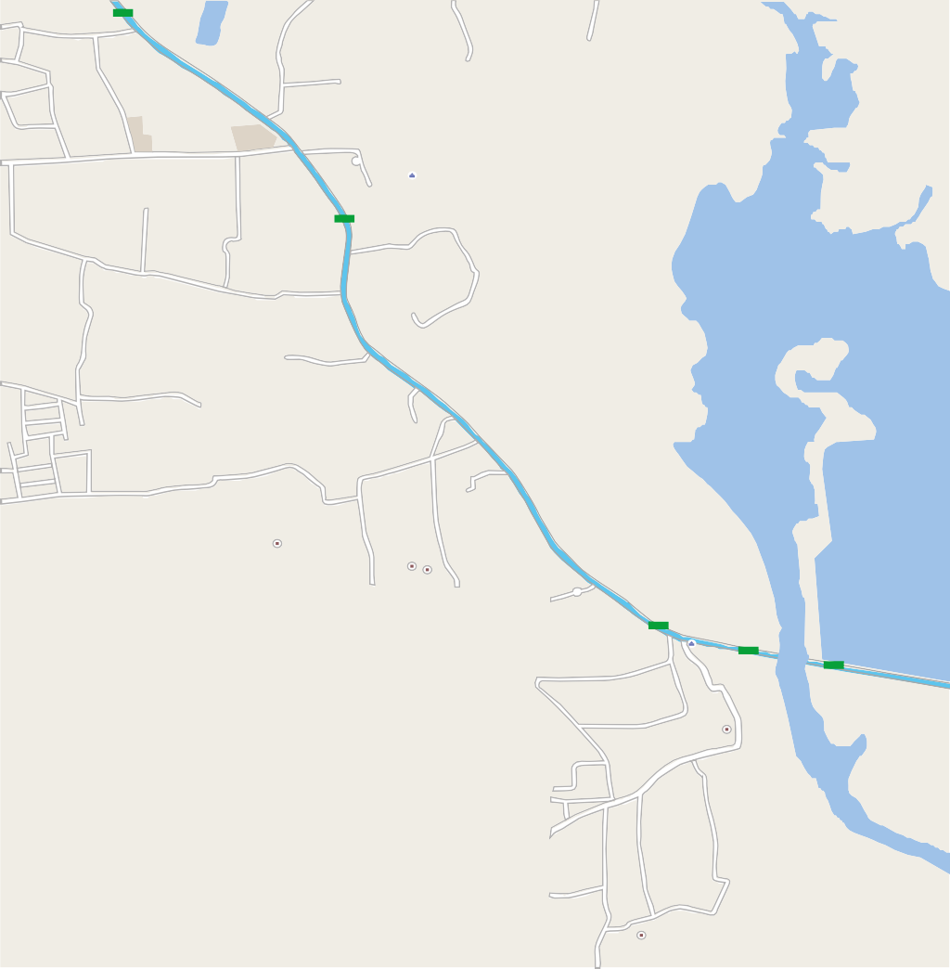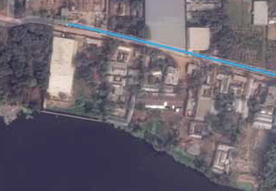

HOW TO FIND US

N302

Unicom Industries Ltd

Zirabo Bazar **Zirabo**

Zirabo High School

Zirabo D.I. College

N302

ABC Footwear

**Muslin Fashions Ltd.**

Sunshine School

Aman Spinning

Azad CNG

Navana CNG Station

Mama Composite

Limited

Airtel Relationship Center

EVE Garments

Little Italy

N302

Ashulia Bazar

N302

N511

Ashulia Bridge

N302

**Muslin Fashions Ltd.**

Ashulia Union Parishad

N511

Mark Terry Ltd

**Muslin Fashions Ltd.**

Holding # 08/848/1, Road # 06 Ward # 08, Block # H

Zirabo, Asholia, Savar, Dhaka

+88 04478035946

+88 04478035947

[info@muslin.biz](mailto:info@muslin.biz)

[www.muslin.biz](http://www.muslin.biz/)

/MuslinFashions

Madrasha Rd

32 [info@muslin.biz](mailto:info@muslin.biz) +88 04478035946-7 [www.muslin.biz](http://www.muslin.biz/)



**Muslin Fashions Ltd.**

Holding # 08/848/1, Road # 06 Ward # 08, Block # H

Zirabo, Asholia, Savar, Dhaka

+88 04478035946

+88 04478035947

[info@muslin.biz](mailto:info@muslin.biz)

[www.muslin.biz](http://www.muslin.biz/)

/MuslinFashions