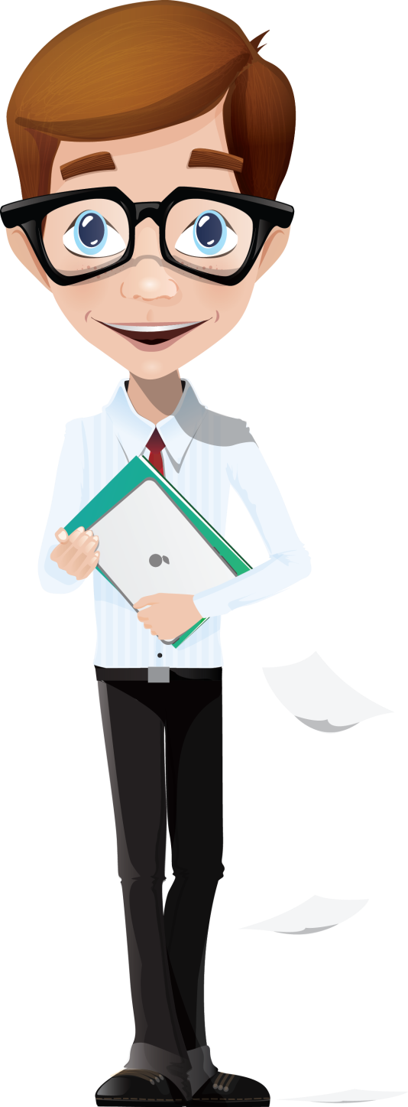
DID YOU KNOW?

When you sleep your mind thinks clear!
When you are thinking to a particular thing, an old problem is solved!

WHY US?

- We teach you for the future
- We know what are the news
- We help you to find the secrets
- We lead you to the top
- We push you to the limit

We think out of the box, so you must do the same.

FOR REGISTRATION:

- Call us : +555.102.304.506
- Email us : office@teacher.co
- Write us : Route 88, No. 77

