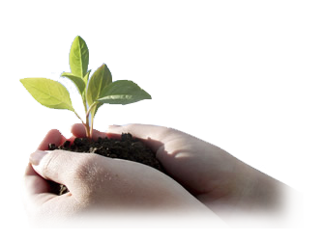

**Free Family event for whole family Come to make your day green and fresh. Free Family event for whole family Come to make your day green and fresh. Free Family event for whole family Come to make your day green and fresh. Free Family event for whole family Come to make your day green and fresh. Free Family event for whole family Come to make your day green and fresh. Free Family event for whole family Come to make your day green and fresh. Free Family event for whole family Come to make your day green and fresh. Free Family event for whole family Come to make your day green and fresh. Free Family event for whole family Come to make your day green and fresh. Free Family event for. Free Family event for whole family Come to make your day green and fresh. Free Family event for whole family Come to make your day green and fresh. Free Family event for whole family Come to make your day green and fresh.**

**Free Family event for whole family**

**Come**

**To make your day green and fresh**

**Garden of Five Senses**

**Saturday August, 2010**

**Second Environment Festival**

**In Regarding Planting**

**Nature & Environment**