# House for Sale

# House picture placeholder

[Address]

[City, ST ZIP Code]

## Call [Name] – [Phone]

### Features and Facts

* [Item]
* [Item]
* [Item]
* [Item]
* [Item]
* [Item]
* [Item]
* [Item]
* [Item]
* [Item]
* [Item]
* [Item]
* [Item]
* [Item]
* [Item]
* [Item]
* [Item]
* [Item]
* [Item]
* [Item]
* [Item]
* [Item]
* [Item]
* [Item]

### Room Sizes

* [Item]
* [Item]
* [Item]
* [Item]

### Schools

* [Item]
* [Item]

### Costs

* [Item]
* [Item]
* [Item]

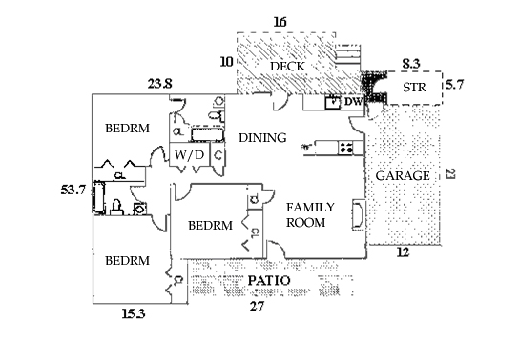Map placeholder

#### Floor Plan

#### Location map