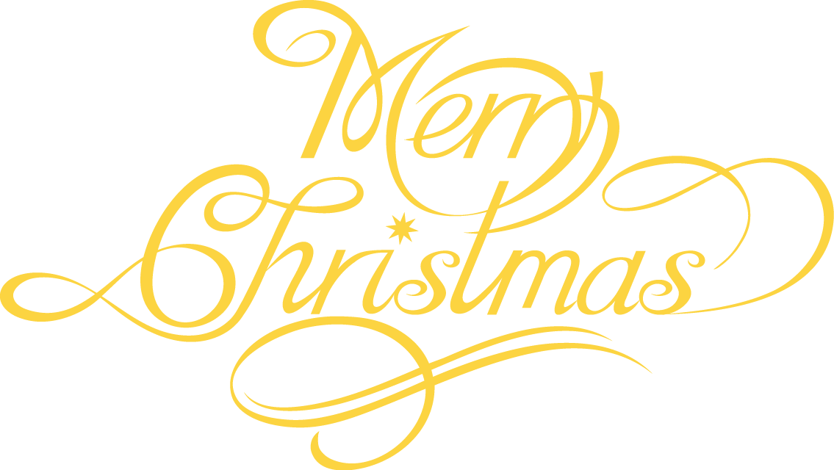

Swiss Restaurant and Night Club

**JOIN US THIS HOLIDAY SEASON**

Saturday December 24th

Dinner Service 5pm and dancing ‘till dawn!

Don’t miss out on a fabulous evening full of dinning, dance, and fun!

Call now for reservations

123-456-7899