

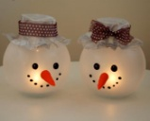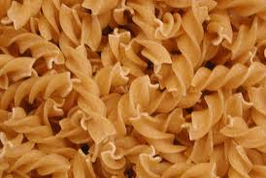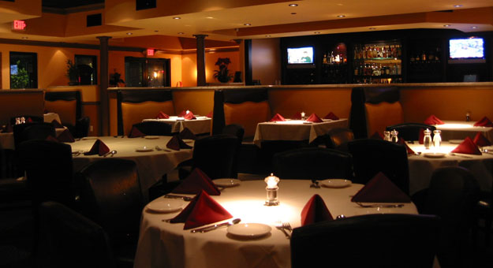

**Special Pasta Items**

* Item 1
* Item 2
* Item 3

**Order Right Now**

**At: 555-555-555**

**www.exampleemail.com**

**Free Delivery Services**

**Luxury & Refreshing** Environment

**Pasta Restaurant**